**UNIVERSITY COLLEGE OF ENGINEERING (BIT CAMPUS), TIRUCHIRAPPALLI**

DEPARTMENT OF CSE



CS6711 SECURITY LAB MANUAL

IV YEAR/VII SEMESTER

CSE – A & B SECTION

Prepared By,

Dr.K.Latha (AP CSE),

Mrs.S.Jayanthi (AP CSE)

**CS6711 -SECURITY LAB**

**OBJECTIVES:**

* Be exposed to the different cipher techniques
* Learn to implement the algorithms DES, RSA,MD5,SHA-1
* Learn to use tools like GnuPG, KF sensor, Vi Strumbler

1. Implement the following SUBSTITUTION & TRANSPOSITION TECHNIQUES concepts:

a) Caesar Cipher

b) Playfair Cipher

c) Hill Cipher

d) Vigenere Cipher

e) Rail fence – row & Column Transformation

2. Implement the following algorithms

a) DES

b) RSA Algorithm

c) Diffiee-Hellman

d) MD5

e) SHA-1

3 Implement the SIGNATURE SCHEME - Digital Signature Standard

4. Demonstrate how to provide secure data storage, secure data transmission and for creating digital signatures (GnuPG).

5. Setup a honey pot and monitor the honeypot on network (KF Sensor)

6. Installation of rootkits and study about the variety of options

7. Perform wireless audit on an access point or a router and decrypt WEP and WPA

8. Demonstrate intrusion detection system (ids) using any tool (snort or any other s/w)

OUTCOMES: At the end of the course, the student should be able to

* Implement the cipher techniques
* Develop the various security algorithms
* Use different open source tools for network security and analysis

LAB EQUIPMENTS FOR A BATCH OF 30 STUDENTS:

SOFTWARE: C / C++ / Java or equivalent

GnuPG or Equivalent , KF Sensor or Equivalent, Snort, Vi Stumbler or Equivalent

HARDWARE: Standalone desktops -30 Nos.

TOTAL: 45 PERIODS

**CS6711 -SECURITY LAB**

**LIST OF EXPERIMENTS**

|  |  |  |
| --- | --- | --- |
| S.No | Name of the Program | |
| 1. Implement the following SUBSTITUTION & TRANSPOSITION TECHNIQUES concepts: | | |
| a) | Caesar Cipher | |
| b) | Playfair Cipher | |
| c) | Hill Cipher | |
| d) | Vigenere Cipher | |
| e) | Rail fence – row & Column Transformation | |
| 2.Implement the following algorithms | | |
| a) | | DES |
| b) | | RSA Algorithm |
| c) | | Diffiee-Hellman |
| d) | | MD5 |
| e) | | SHA-1 |
|  | | Implement the SIGNATURE SCHEME - Digital Signature Standard |
|  | | Demonstrate how to provide secure data storage, secure data transmission and for creating digital signatures (GnuPG). |
|  | | Setup a honey pot and monitor the honeypot on network (KF Sensor) |
|  | | Installation of rootkits and study about the variety of options |
|  | | Perform wireless audit on an access point or a router and decrypt WEP and WPA.(Vi Stumbler) |
|  | | Demonstrate intrusion detection system (ids) using any tool (snort or any other s/w) |

**EX:NO:1A**

**IMPLEMENTATION OF CAESAR CIPHER**

**AIM:**

To implement the simple substitution technique named Caesar cipher using C++ language.

**ALGORITHM:**

STEP-1: Read the plain text from the user.

STEP-2: Read the key value from the user.

STEP-3: If the key is positive then encrypt the text by adding the key with each

character in the plain text.

STEP-4: Else subtract the key from the plain text.

STEP-5: Display the cipher text obtained above.

**PROGRAM:**

#include<iostream.h>

#include<string.h>

#include<conio.h>

void main() {

cout<<"Enter the message:\n";

char plain[100];

cin.getline(plain,100);

int i,j,ch,choice,key;

cout << "Enter key: ";

cin >> key;

cout<<"Enter your choice \n1. Encryption \n2. Decryption \n";

cin>>choice;

if (choice==1)

{

for(int i = 0; plain[i] != '\0'; ++i) {

ch = plain[i];

if(ch >= 'a' && ch <= 'z')

{

ch = ch + key;

if (ch > 'z') {

ch = ch - 'z' + 'a' - 1;

}

plain[i] = ch;

}

cout<<"Encrypted message: "<< msg;

}

else if(choice == 2)

{

for(int i = 0; plain[i] != '\0'; ++i) {

ch = plain[i];

if(ch >= 'a' && ch <= 'z') {

ch = ch - key;

if (ch > 'a') {

ch = ch - 'z' - 'a' + 1;

}

plain[i] = ch;

}

cout << "Decrypted message: " << msg;

}

getch();

}

**OUTPUT**

Enter the message:helloz

Enter the key:2

Enter your choice:1

Encrypted Message:jgnnqb

Enter the message:jgnnqb

Enter the key:2

Enter your choice:2

Decrypted Message:helloz

**RESULT**

Thus the implementation of Caesar cipher had been executed successfully..

**EX:NO:1B**

**IMPLEMENTATION OF PLAYFAIR CIPHER**

**AIM:**

To write a C program to implement the playfair substitution technique.

**ALGORITHM:**

Step1:Read the keyword from the user.

Step2:Arrange the keywords without duplicates in a 5x5 matrix in the row order and fill the remaining cells with missed out letters in alphabetical order. Note that i and j takes the same cell.

Step3:Read the plain text from the user.

Step4:Group the plain text in pairs and match the corresponding corner letters by forming a rectangular grid.

Step5:Display the obtained cipher Text.

**PROGRAM:**

#include<stdio.h>

#include<conio.h>

#include<string.h>

#define MX 5

void play(char p1,char p2,char arr[MX][MX]);

int removeSpaces(char* plain,int ps);

void encrypt(char pt[],char keyword[]);

void main(){

int i,j,k=0,l,m=0,n;

char pt[10],arr[MX][MX],keyremain[25],keyword[10];

char alpha[26]={'A','B','C','D','E','F','G','H','I','J','K','L','M','N','O','P','Q','R','S','T','U','V','W','X','Y','Z'};

clrscr();

printf("\n Enter Keyword:");

gets(keyword);

n=strlen(keyword);

for(i=0;i<n;i++)

{

if(keyword[i]=='j')keyword[i]='i';

else if(keyword[i]=='J')keyword[i]='I';

keyword[i]=toupper(keyword[i]);

}

j=0;

for(i=0;i<26;i++)

{

for(k=0;k<n;k++)

{

if(keyword[k]==alpha[i])

break;

else if(alpha[i]=='J')

break;

}

if(k==n)

{

keyremain[j]=alpha[i];

j++;

}

}

k=0;

for(i=0;i<MX;i++)

{

for(j=0;j<MX;j++)

{

if(k<n)

{

arr[i][j]=keyword[k];

k++;

}

else

{

arr[i][j]=keyremain[m];

m++;

}

printf("%c\t",arr[i][j]);

}

printf("\n");

}

printf("\n Enter the Plaintext:");

gets(pt);

for(i=0;i<strlen(pt);i++)

{

if(pt[i]=='j')pt[i]='i';

else if(pt[i]=='J')pt[i]='I';

pt[i]=toupper(pt[i]);

}

encrypt(pt,keyword);

printf("plain text:%s\n cipher text:",pt);

for(i=0;i<strlen(pt);i++)

{

if(pt[i]=='J')pt[i]='I';

if(pt[i+1]==NULL)

play(pt[i],'X',arr);

else

{

if(pt[i+1]=='J')pt[i+1]='I';

if(pt[i]==pt[i+1])

play(pt[i],'X',arr);

else

{

play(pt[i],pt[i+1],arr);

i++;

}}}

getch();

}

void play(char p1,char p2,char arr[MX][MX])

{

int i,j,r1,r2,c1,c2,option;

for(i=0;i<MX;i++)

{

for(j=0;j<MX;j++)

{

if(p1==arr[i][j])

{

r1=i;

c1=j;

}

else if(p2==arr[i][j])

{

r2=i;

c2=j;

}

}

}

if(r1==r2)

{

if(option==1)

{

c1=(c1+1)%5;

c2=(c2+1)%5;

}

else

printf("%c%c",arr[r1][c1],arr[r2][c2]);

}

else if(c1==c2)

{

if(option==1)

{

r1=(r1+1)%5;

r2=(r2+1)%5;

}

printf("%c%c",arr[r1][c1],arr[r2][c2]);

}

else

{

printf("%c%c",arr[r1][c2],arr[r2][c1]);

}

}

int removeSpaces(char* plain,int ps)

{

int i,count=0;

for(i=0;i<ps;i++)

if(plain[i]!=' ')

plain[count++]=plain[i];

plain[count]='\0';

return count;

}

void encrypt(char pt[],char keyword[])

{

char ps,ks;

ks=strlen(keyword);

ks=removeSpaces(keyword,ks);

ps=strlen(pt);

ps=removeSpaces(pt,ps); }

**OUTPUT:**

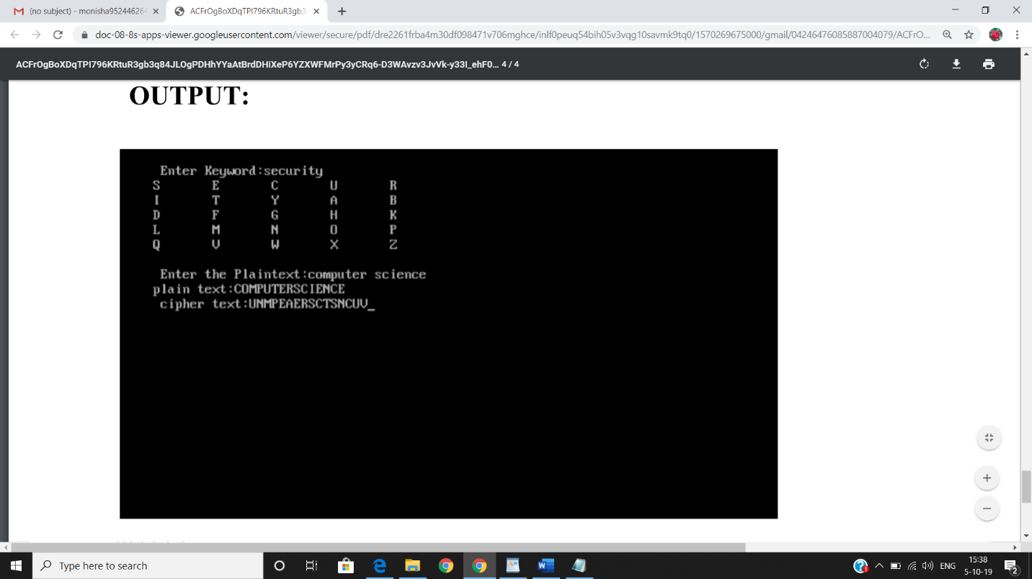

**RESULT:**

Thus the playfair cipher substitution technique had been implemented successfully.

**EX:NO:1c**

**IMPLEMENTATION OF HILL CIPHER**

**AIM:**

To write a C program to implement the hill cipher substitution techniques.

**ALGORITHM:**

STEP-1: Read the plain text and key from the user.

STEP-2: Split the plain text into groups of

STEP-3: Arrange the keyword in a 3*3 matrix.

STEP-4: Multiply the two matrices to obtain the cipher text of length three.

STEP-5: Combine all these groups to get the complete cipher text.

**PROGRAM: (Hill Cipher)**

#include<stdio.h>

#include<conio.h>

#include<string.h>

void main()

{

unsigned int a[3][3]={{6,8,9},{9,7,8},{12,14,17}};

unsigned int b[3][3]={{10,5,8},{3,5,8},{7,21,9}};

int i,j, t=0;

unsigned int c[30],d[30];

char msg[20];

clrscr();

printf("Enter plain text \n”);

scanf("%s",msg);

for(i=0;i<strlen(msg);i++)

{

c[i]=msg[i]-65;

printf("%d ",c[i]);

}

for(i=0;i<3;i++)

{

t=0;

for(j=0;j<3;j++)

{

t=t+(a[i][j]*c[j]);

}

d[i]=t%26;

}

for(i=0;i<3;i++)

printf("\nEncrypted Cipher Text :

%c",d[i]+65);

{

t=0;

for(j=0;j<3;j++)

{

t=t+(b[i][j]*d[j]);

}

c[i]=t%26;

}

for(i=0i<3;i++)

printf("\n Decrypted Cipher Text :%c",c[i]+65);

Decrypted Cipher Text :%c",c[i]+65);

getch();

}

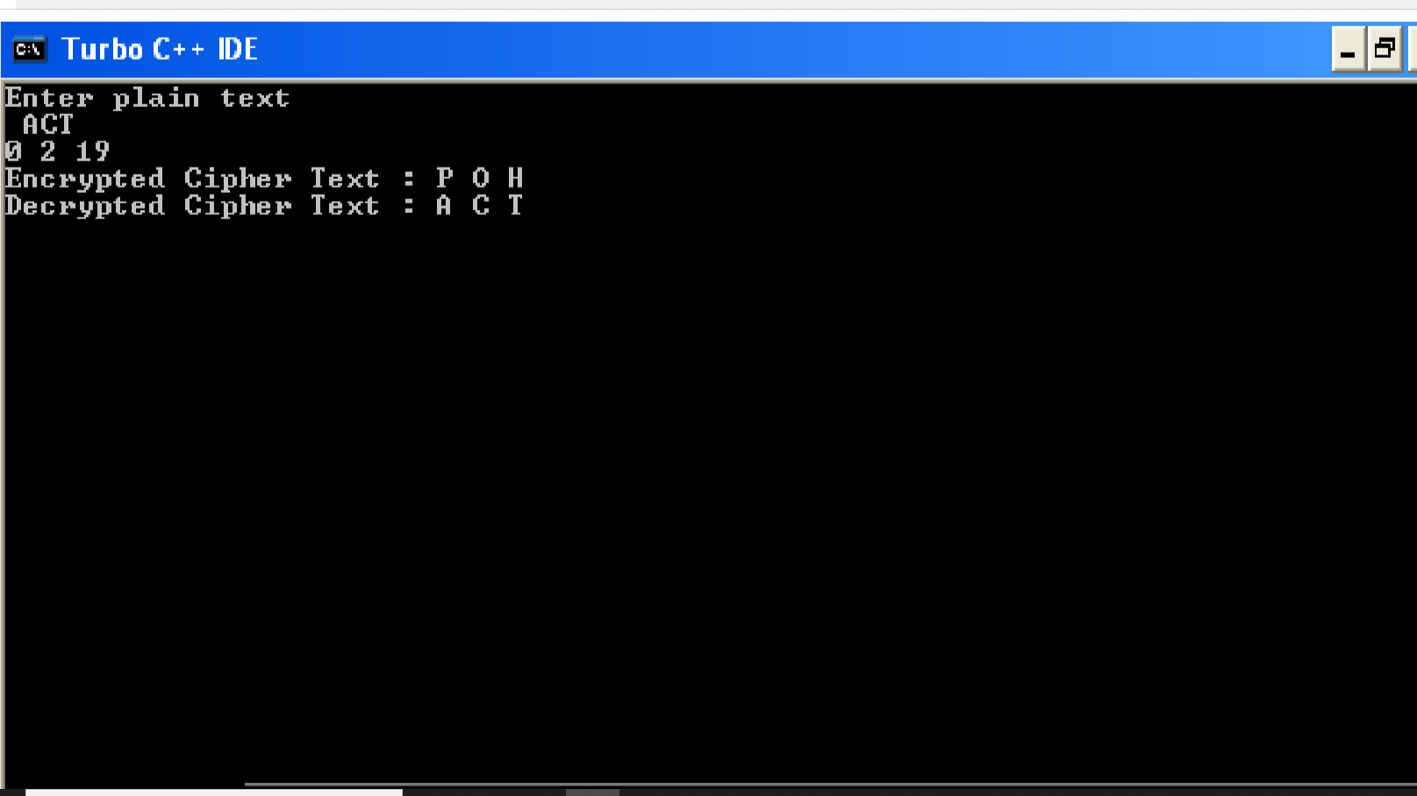

**RESULT:**

Thus the hill cipher substitution technique has been implemented successfully in C.

**EX:NO:1d**

**VIGENERE CIPHER**

**AIM:**

To implement a program for encryption and decryption using vigenere cipher substitution technique

**ALGORITHM:**

1. The Vigenere cipher is a method of encrypting alphabetic text by using a series of different Caesar ciphers based on the letters of a keyword.
2. It is a simple form of polyalphabetic substitution.
3. To encrypt, a table of alphabets can be used, termed a Vigenere square, or Vigenere table.
4. It consists of the alphabet written out 26 times in different rows, each alphabet shifted cyclically to the left compared to the previous alphabet, corresponding to the 26 possible Caesar ciphers.
5. At different points in the encryption process, the cipher uses a different alphabet from one of the rows used.
6. The alphabet at each point depends on a repeating keyword.

**PROGRAM:**

import java.util.*;

class vigenereCipher

{

static String encode(String text, final String key)

{

String res = "";

text = text.toUpperCase();

for (int i = 0, j = 0; i < text.length(); i++)

{

char c = text.charAt(i);

if (c < 'A' || c > 'Z')

{

continue;

}

res += (char)((c + key.charAt(j) - 2 * 'A') % 26 + 'A');

j = ++j % key.length();

}

return res;

}

static String decode(String text, final String key)

{

String res = "";

text = text.toUpperCase();

for (int i = 0, j = 0; i < text.length(); i++) {

char c = text.charAt(i);

if (c < 'A' || c > 'Z')

{

continue;

}

res += (char)((c - key.charAt(j) + 26) % 26 + 'A');

j = ++j % key.length();

}

return res;

}

public static void main (String[] args) throws java.lang.Exception

{

String key = "VIGENERECIPHER";

String msg = "SecurityLaboratory";

System.out.println("simulation of Vigenere Cipher");

System.out.println("input message : " + msg);

String enc = encode(msg, key);

System.out.println("encoded message : " + enc);

System.out.println("decoded message : " + decode(enc, key));

}

}

**OUTPUT:**

simulation of Vigenere Cipher

input message : SecurityLaboratory

encoded message : NMIYEMKCNIQVVROWXC

decoded message : SECURITYLABORATORY

**RESULT:**

Thus the program was executed and verified successfully.

**EX:NO:1E**

**IMPLEMENTATION OF RAIL FENCE – ROW & COLUMN TRANSFORMATION TECHNIQUE**

**AIM:**

To write a program to implement the rail fence transformation technique.

**ALGORITHM:**

STEP-1: Get the Plain text and key value.

STEP-2: Assign key value as row and the length of the plain text as column.

STEP-3: Enter the plain text characters in the matrix using the condition

STEP-4: read the characters row wise in the matrix to get the cipher text.

STEP-5:In decription, enter the input as output of the encryption.

STEP-6:Assign key value as row and the length of the encrypted text as column.

STEP-7:Assign the asterisk in the matrix using the condition.

STEP-8:text character replaced the position of the asterisk using the condition.

STEP-9;Read the characters in the matrix to get the plain text.

**PROGRAM:**

import java.util.Scanner;

public class Rail

{

public static void main(String[] args)

{

Scanner in=new Scanner(System.in);

System.out.println("enter plain text");

String plaintext=in.nextLine();

System.out.println("enter key:");

int key=in.nextInt();

System.out.println("encrypted text");

String en=encryption(plaintext,key);

System.out.println(en);

System.out.println("decrypted text");

System.out.println(decryption(en,key));

}

static String encryption(String text,int key)

{

String encryptedtext="";

boolean check=false;

int i=0,j=0;

int k;

int row=key;

int col=text.length();

char[][] a= new char[row][col];

for(i=0;i<col;i++)

{

if(j==0||j==key-1)

check=!check;

a[j][i]=text.charAt(i);

if(check)

j++;

else

j--;

}

for(i=0;i<row;i++)

{

for(k=0;k<col;k++)

{

if(a[i][k] !=0)

encryptedtext +=a[i][k];

}

}

return encryptedtext;

}

static String decryption(String text,int key)

{

String decryptedtext="";

boolean check=false;

int i=0,j=0;

int k;

int row=key;

int col=text.length();

char[][] a= new char[row][col];

for(i=0;i<col;i++)

{

if(j==0||j==key-1)

check=!check;

a[j][i]='*';

if(check)

j++;

else

j--;

}

int index=0;

check=false;

for(i=0;i<row;i++)

{

for(k=0;k<col;k++)

{

if(a[i][k]=='*'&&index<col)

{

a[i][k]=text.charAt(index++);

}

}

}

j=0;

for(i=0;i<col;i++)

{

if(j==0||j==key-1)

check=!check;

decryptedtext +=a[j][i];

if(check)

j++;

else

j--;

}

return decryptedtext;

}

}

**OUTPUT:**

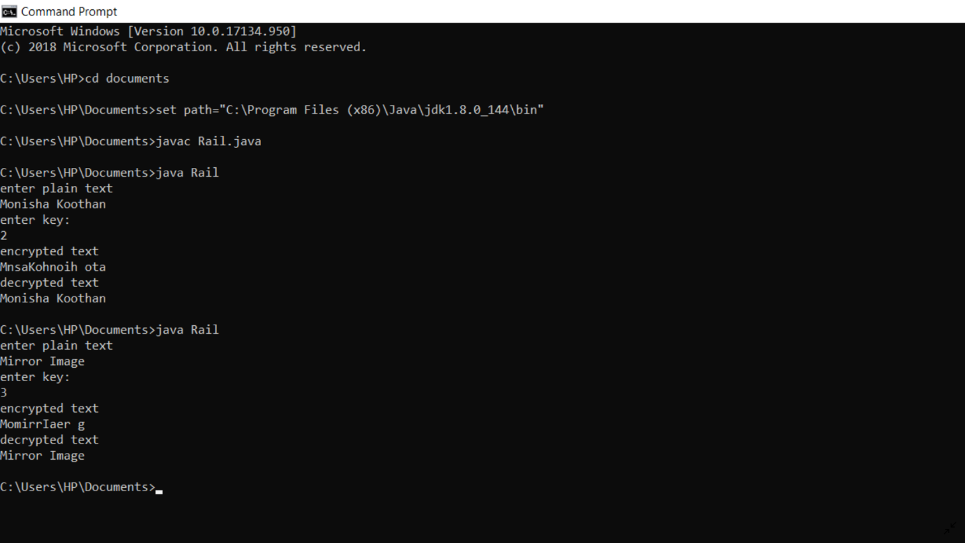

**RESULT:**

Thus the rail fence algorithm had been executed successfully.

**EX:NO:2A**

**IMPLEMENTATION OF DES**

**AIM:**

To write a C program to implement Data Encryption Standard (DES) using java Language.

**Algorithym:**

1. DES is a symmetric encryption system that uses 64-bit blocks, 8 bits of which are
2. used for parity checks. The key therefore has a "useful" length of 56 bits, which means that
3. only 56 bits are actually used in the algorithm. The algorithm involves carrying out
4. combinations, substitutions and permutations between the text to be encrypted and the key,
5. while making sure the operations can be performed in both directions. The key is ciphered on
6. 64 bits and made of 16 blocks of 4 bits, generally denoted k1 to k16. Given that "only" 56 bits are actually used for encrypting, there can be 256 different keys.

**Program:**

import javax.swing.*;

import java.security.SecureRandom;

import javax.crypto.Cipher;

import javax.crypto.KeyGenerator;

import javax.crypto.SecretKey;

import javax.crypto.spec.SecretKeySpec;

import java.util.Random ;

class DES

{

byte[] skey = new byte[1000];

String skeyString; static byte[] raw;

String inputMessage,encryptedData,decryptedMessage;

public DES()

{

try

{

generateSymmetricKey();

inputMessage=JOptionPane.showInputDialog(null,"Enter message to encrypt");

byte[] ibyte = inputMessage.getBytes();

byte[] ebyte=encrypt(raw, ibyte);

String encryptedData = new String(ebyte);

System.out.println("Encrypted message "+encryptedData);

JOptionPane.showMessageDialog(null,"Encrypted Data "+"\n"+encryptedData);

byte[] dbyte= decrypt(raw,ebyte);

String decryptedMessage = new String(dbyte);

System.out.println("Decrypted message "+decryptedMessage);

JOptionPane.showMessageDialog(null,"Decrypted Data "+"\n"+decryptedMessage);

}

catch(Exception e)

{

System.out.println(e);

}

}

void generateSymmetricKey()

{

try

{

Random r = new Random();

int num = r.nextInt(10000);

String knum = String.valueOf(num);

byte[] knumb = knum.getBytes();

skey=getRawKey(knumb);

skeyString = new String(skey);

System.out.println("DES Symmetric key = "+skeyString);

}

catch(Exception e)

{

System.out.println(e);

}

}

private static byte[] getRawKey(byte[] seed) throws Exception

{

KeyGenerator kgen = KeyGenerator.getInstance("DES");

SecureRandom sr = SecureRandom.getInstance("SHA1PRNG");

sr.setSeed(seed);

kgen.init(56, sr);

SecretKey skey = kgen.generateKey();

raw = skey.getEncoded();

return raw;

}

private static byte[] encrypt(byte[] raw, byte[] clear) throws Exception

{

SecretKeySpec skeySpec = new SecretKeySpec(raw, "DES");

Cipher cipher = Cipher.getInstance("DES");

cipher.init(Cipher.ENCRYPT_MODE, skeySpec);

byte[] encrypted = cipher.doFinal(clear);

return encrypted;

}

private static byte[] decrypt(byte[] raw, byte[] encrypted) throws Exception

{

SecretKeySpec skeySpec = new SecretKeySpec(raw, "DES");

Cipher cipher = Cipher.getInstance("DES");

cipher.init(Cipher.DECRYPT_MODE, skeySpec);

byte[] decrypted = cipher.doFinal(encrypted);

return decrypted;

}

public static void main(String args[])

{

DES des = new DES();

}

}

**OUTPUT:**

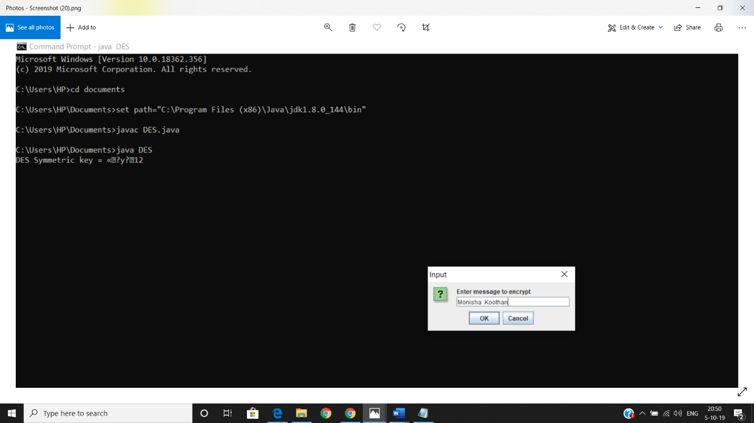

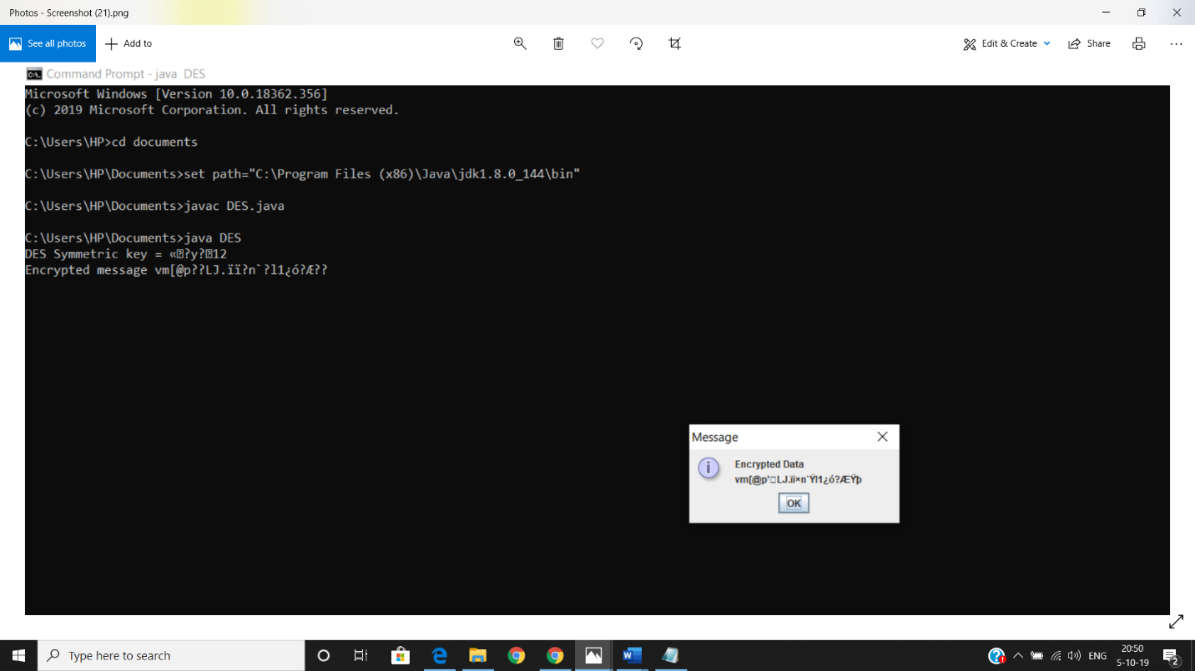

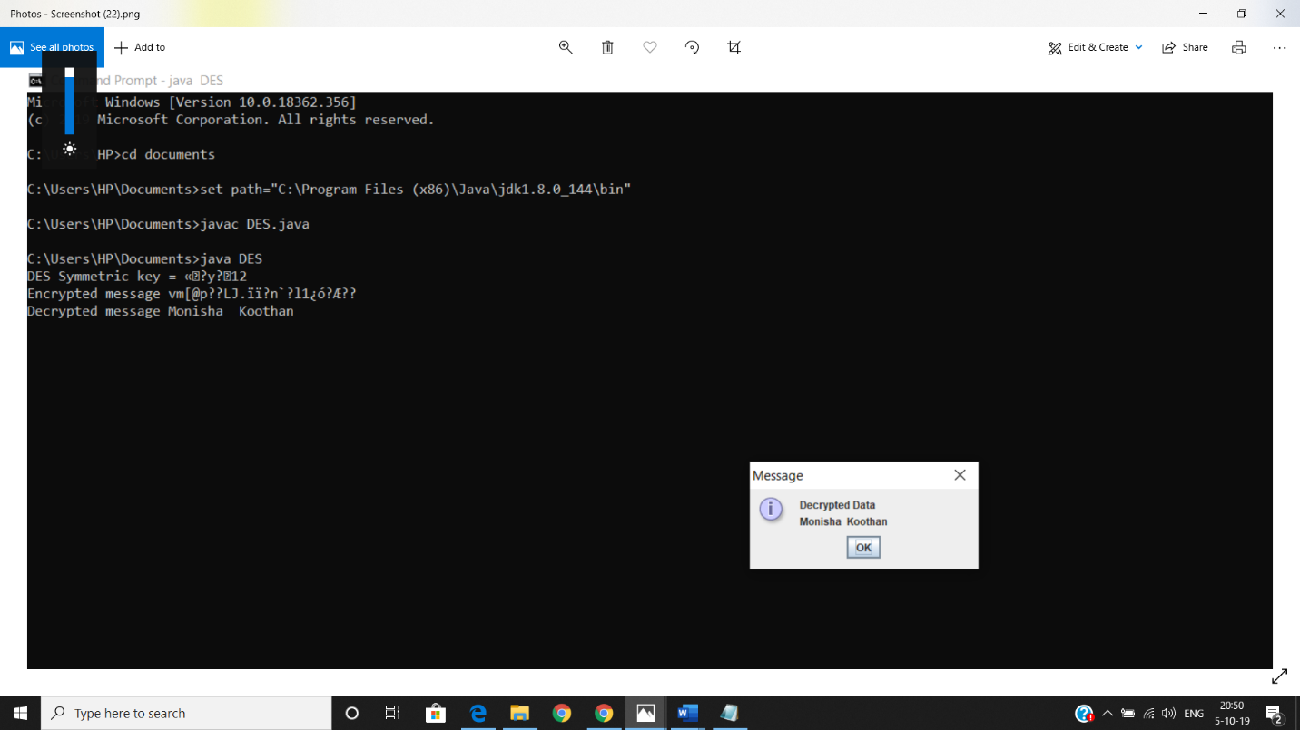

**RESULT:**

Thus the data encryption standard algorithm had been implemented successfully using java language.

**EX:NO:2B**

**RSA ALGORITHM**

**AIM:**

**T**o write a C++ program to implement the RSA encryption algorithm.

**ALGORITHM:**

**STEP-1**: Select two co-prime numbers as **p** and **q.**

**STEP-2**: Compute **n =p * q** .

**STEP-3**: Compute **(p-1)*(q-1)** and store it in z.

**STEP-4**: Select a random prime number e that is less than that of z, i.e

1<e<z.

**STEP-5**: Compute the private key, d as e * mod-1(z) i.e d = e*(mod-1Z), for any k.

**STEP-6**: The cipher text is computed as **me mod n.**

**STEP-7**: Decryption is done as ciphered mod as **cd mod n**.

**PROGRAM:**

#include<iostream.h>

#include<conio.h>

#include<math.h>

int gcd(int a, int b) {

int temp;

do {

temp= a%b;

if(temp==0)

return b;

a = b;

b= temp;

}while(1);

}

void main() {

double p;

double q;

clrscr();

cout<<"enter the value of p:";

cin>>p;

cout<<"\n p value is:"<<p;

cout<<"\n enter the value of q:";

cin>>q;

cout<<"\n q value is:"<<q;

double n=p*q;

double track;

double phi= (p-1)*(q-1);

double e=9;

while(e<phi) {

track = gcd(e,phi);

if(track==1)

break;

else

e++;

}

double d1=1/e;

double d=fmod(d1,phi);

double message = 17;

double c = pow(message,e);

double m = pow(c,d);

c=fmod(c,n);

m=fmod(m,n);

cout<<"\n Original Message = "<<message;

cout<<"\n"<<"p = "<<p;

cout<<"\n"<<"q = "<<q;

cout<<"\n"<<"n = pq = "<<n;

cout<<"\n"<<"phi = "<<phi;

cout<<"\n"<<"e = "<<e;

cout<<"\n"<<"d = "<<d;

cout<<"\n"<<"Encrypted message = "<<c;

cout<<"\n"<<"Decrypted message = "<<m;

getch();

}

**OUTPUT:**

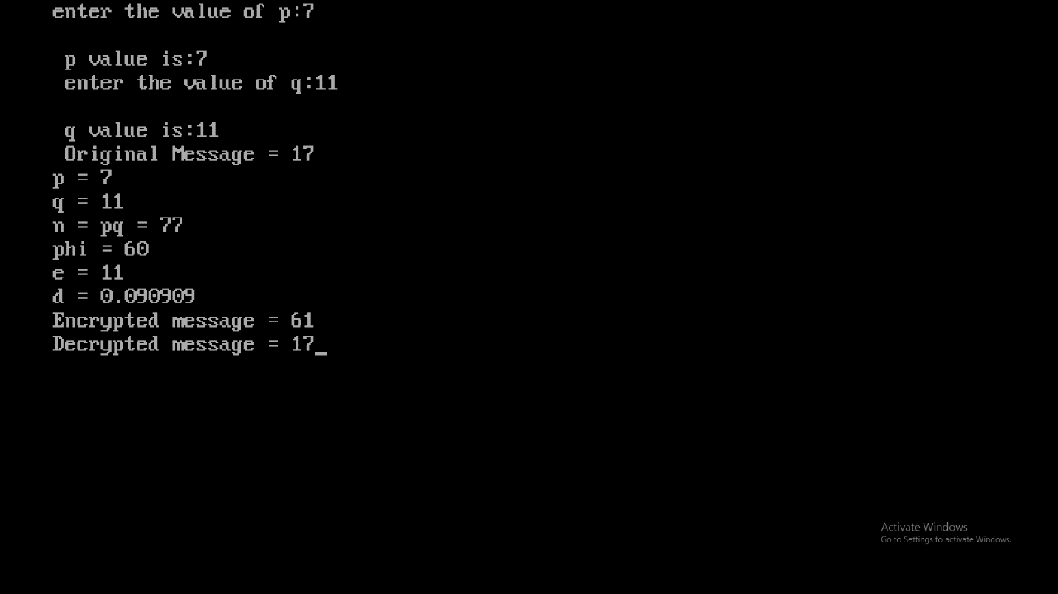

**RESULT:**

Thus the C++ program to implement encryption technique has

been implemented successfully**.**

**EX:NO:2C**

**DIFFIE HELLMAN KEY EXCHANGE ALGORITHM**

**AIM:**

To implement the Diffie-Hellman Key Exchange algorithm using C++ language.

**ALGORITHM:**

STEP-1: Both Alice and Bob shares the same public keys g and p.

STEP-2: Alice selects a random public key a.

STEP-3: Alice computes his secret key A as ga mod p.

STEP-4: Then Alice sends A to Bob.

STEP-5: Similarly Bob also selects a public key b and computes his secretkey as B and sends the same back to Alice.

STEP-6: Now both of them compute their common secret key as the otherone’s secret key power of a mod p.

**PROGRAM:**

#include<conio.h>

#include<iostream.h>

#include<math.h>

int pow(int,int,int);

void main()

{

long int g,p,a,b,k1,k2,x,y;

clrscr();

cout<<"\nEnter value of p";

cin>>p;

cout<<"\nEnter value of g";

cin>>g;

cout<<"\nEnter values of a and b:";

cin>>a>>b;

x=pow(g,a,p);

cout<<"\nalice end value:"<<x;

y=pow(g,b,p);

cout<<"\nbob end value:"<<y;

k1=pow(y,a,p);

cout<<"\n\t valueof k1 :"<<k1;

k2=pow(x,b,p);

cout<<"\n\t valueof k2 :"<<k2;

getch();

}

int pow(int n,int g,int x)

{

long int a,a1;

a1=pow(n,g);

a=a1%x;

return a;

}

**OUTPUT:**

Enter value of p:23

Enter value of g:9

enter the values of a and b:4 3

alice end value:6

bob end value:16

value of k1:9

value of k2:9

**RESULT:**

Thus the c++ program for implementation of Diffie Hellman key exchange algorithm has been successfully executed **.**

**EX:NO:2d**

**IMPLEMENTATION OF MD5**

**AIM:**

To write a C program to implement the MD5 hashing technique.

**ALGORITHM:**

STEP-1: Read the 128-bit plain text.

STEP-2: Divide into four blocks of 32

STEP-3: Compute the functions f, g, h and i with operations such as, rotations, permutations, etc,.

STEP-4: The output of these functions are combined together as F and performed circular shifting and then given to key round.

STEP-5: Finally, right shift of ‘s’ times are performed and the results are combined together to produce the final output.

**PROGRAM:**

#include <stdlib.h>

#include <stdio.h>

#include <string.h>

#include <math.h>

#include<conio.h>

typedef union uwb

{

unsigned w;

unsigned char b[4];

}

MD5union;

typedef unsigned DigestArray[4];

unsigned func0( unsigned abcd[] )

{

return ( abcd[1] & abcd[2]) | (~abcd[1] & abcd[3]);

}

unsigned func1( unsigned abcd[] )

{

return ( abcd[3] & abcd[1]) | (~abcd[3] & abcd[2]);

}

unsigned func2( unsigned abcd[] )

{

return abcd[1] ^ abcd[2] ^ abcd[3];

}

unsigned func3( unsigned abcd[] )

{

return abcd[2] ^ (abcd[1] |~ abcd[3]);

}

typedef unsigned (*DgstFctn)(unsigned a[]);

unsigned *calctable( unsigned *k)

{

double s, pwr;

int i;

pwr = pow( 2, 32);

for (i=0; i<64; i++)

{

s = fabs(sin(1+i));

k[i] = (unsigned)( s * pwr );

}

return k;

}

unsigned rol( unsigned r, short N )

{

unsigned mask1 = (1<<N) -1;

return ((r>>(32-N)) & mask1) | ((r<<N) & ~mask1);

}

unsigned *md5( const char *msg, int mlen)

{

static DigestArray h0 = { 0x67452301, 0xEFCDAB89, 0x98BADCFE, 0x10325476 };

static DgstFctn ff[] = { &func0, &func1, &func2, &func3};

static short M[] = { 1, 5, 3, 7 };

static short O[] = { 0, 1, 5, 0 };

static short rot0[] = { 7,12,17,22};

static short rot1[] = { 5, 9,14,20};

static short rot2[] = { 4,11,16,23};

static short rot3[] = { 6,10,15,21};

static short *rots[] = {rot0, rot1, rot2, rot3 };

static unsigned kspace[64];

static unsigned *k;

static DigestArray h;

DigestArray abcd;

DgstFctn fctn;

short m, o, g;

unsigned f;

short *rotn;

union

{

unsigned w[16];

cha b[64];

}mm;

int os = 0;

int grp, grps, q, p;

unsigned char *msg2;

if (k==NULL) k= calctable(kspace);

for (q=0; q<4; q++) h[q] = h0[q];

// initialize

{

grps = 1 + (mlen+8)/64;

msg2 = malloc( 64*grps);

memcpy( msg2, msg, mlen);

msg2[mlen] = (unsigned char)0x80;

q = mlen + 1;

while (q < 64*grps){ msg2[q] = 0; q++ ;

}

{

MD5union u;

u.w = 8*mlen;

q -= 8;

memcpy(msg2+q, &u.w, 4 );

}

}

for (grp=0; grp<grps; grp++)

{

memcpy( mm.b, msg2+os, 64);

for(q=0;q<4;q++) abcd[q] = h[q];

for (p = 0; p<4; p++)

{

fctn = ff[p];

rotn = rots[p];

m = M[p]; o= O[p];

for (q=0; q<16; q++)

{

g = (m*q + o) % 16;

f = abcd[1] + rol( abcd[0]+ fctn(abcd)+k[q+16*p] + mm.w[g], rotn[q%4]);

abcd[0] = abcd[3];

abcd[3] = abcd[2];

abcd[2] = abcd[1];

abcd[1] = f;

}

}

for (p=0; p<4; p++) h[p] += abcd[p];

os += 64;

}

return h;

}

void main()

{

int j,k;

const char *msg = "The quick brown fox jumps over the lazy dog";

unsigned *d = md5(msg, strlen(msg));

MD5union u;

clrscr();

printf("\t MD5 ENCRYPTION ALGORITHM IN C \n\n");

printf("Input String to be Encrypted using MD5 :\n\t%s",msg);

printf("\n\nThe MD5 code for input string is: \n");

printf("\t= 0x");

for (j=0;j<4; j++)

{

u.w = d[j];

for (k=0;k<4;k++) printf("%02x",u.b[k]);

}

printf("\n");

printf("\n\t MD5 Encyption Successfully Completed!!!\n\n");

getch();

system("pause");

getch();

}

**OUTPUT:**

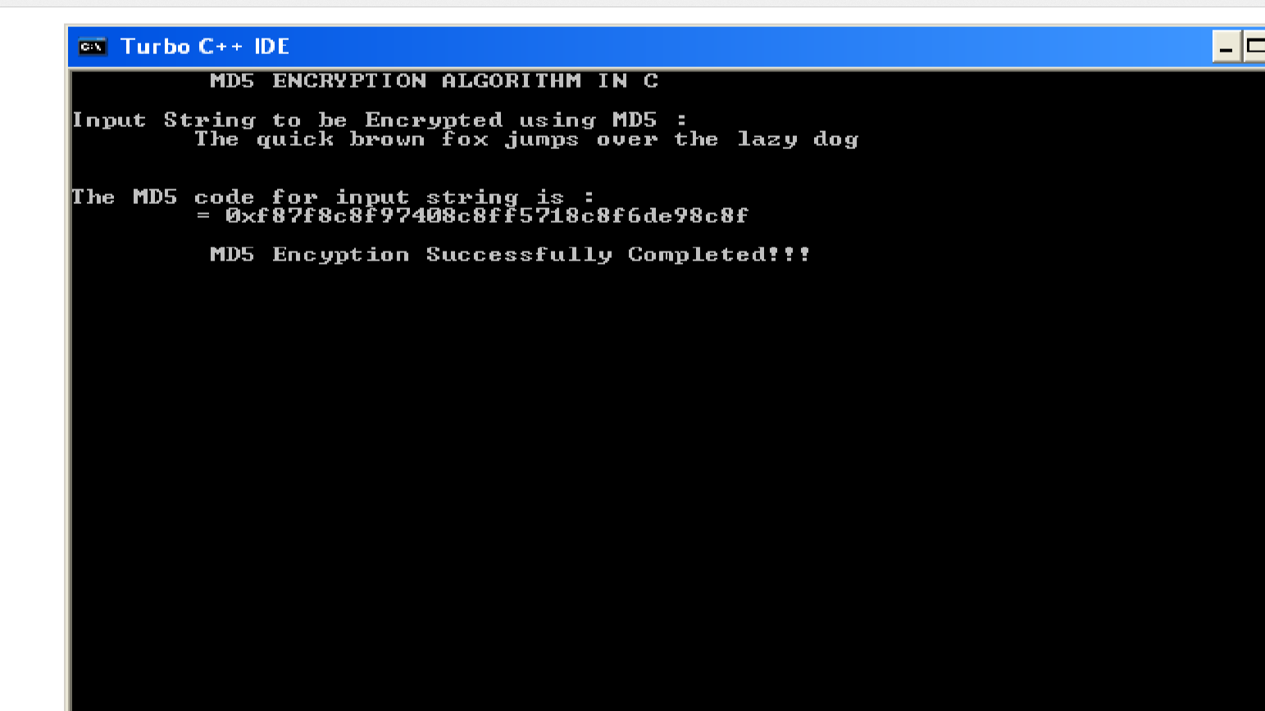

**RESULT:**

Thus the implementation of MD5 hashing algorithm had been implemented successfully using C.

**EX:NO:2D**

**SHA – 1**

**Aim:**

**To implement the SHA-I hashing technique using java program.**

**Algorithm:**

Step1: Enter the string for which the hash value(message digest) has to be obtained.

Step2: Use the getInstance() method to initialize the SHA – 1 algorithm under “java.security”.After that using the messageDigest method check whether the algorithm is working.

Step3: Then the message digest value is calculated and the results are returned as a byte array.

Step4:  BigInteger class is used, to convert the resultant byte array into its sign number representation.

Step5: Then the sign number representation is then converted into a hexadecimal format to get the expected MessageDigest.

Step6: Print the expected message digest of the given string.

**Program:**

import java.math.BigInteger;

import java.security.MessageDigest;

import java.security.NoSuchAlgorithmException;

import java.util.Scanner;

public class Sha1 {

public static String convertStringToHex(String input)

{

try {

MessageDigest mgd = MessageDigest.getInstance("SHA-1");

System.out.println(" Algorithm name = " +mgd.getAlgorithm());

System.out.println(" Provider of the algorithm= " +mgd.getProvider());

System.out.println(" ToString = " +mgd.toString());

byte[] msgd = mgd.digest(input.getBytes());

BigInteger num = new BigInteger(1, msgd);

String hashvalue = num.toString(16);

while (hashvalue.length() < 32)

{

hashvalue = "0" + hashvalue;

}

return hashvalue;

}

catch (NoSuchAlgorithmException e)

{

throw new RuntimeException(e);

}

}

public static void main(String args[])throws NoSuchAlgorithmException

{

System.out.println("Enter a string to find the hash code ");

Scanner in = new Scanner(System.in);

String s1 = in.nextLine();

System.out.println("\n" + s1 + " : " + convertStringToHex(s1));

} }

**Output:**

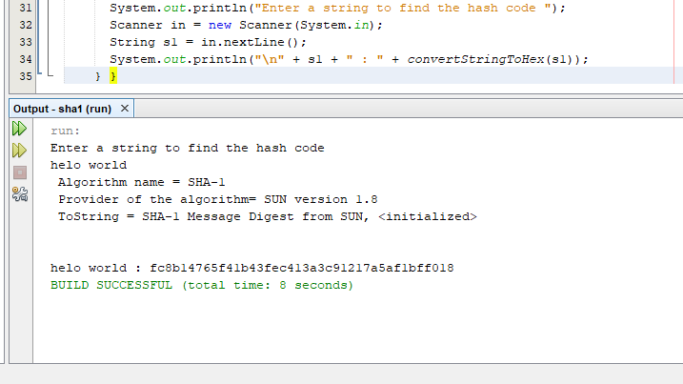

**RESULT:**

Thus the implementation of SHA-1 hashing algorithm had been implemented successfully using java.

**EX:NO:3**

**IMPLEMENTATION OF DIGITAL SIGNATURE STANDARD**

**AIM:**

To write a java program to implement the signature scheme named digital signature standard (Euclidean Algorithm).

**ALGORITHM:**

STEP-1: A and B are investigating a forgery case of x and y.

STEP-2: X had document signed by him but he says he did not sign that document digitally.

STEP-3: A reads the two prime numbers p and a.

STEP-4: He chooses a random co-primes alpha and beta and the x’s original signature x.

STEP-5: With these values, he applies it to the elliptic curve cryptographic equation to obtain y.

STEP-6: Comparing this ‘y’ with actual y’s document, A concludes that y is a forgery.

**PROGRAM: (Digital Signature Standard)**

import java.util.*;

import java.math.BigInteger;

class dss {

final static BigInteger one = new BigInteger("1");

final static BigInteger zero = new BigInteger("0");

public static BigInteger getNextPrime(String ans)

{

BigInteger test = new BigInteger(ans);

while (!test.isProbablePrime(99))

e:

{

test = test.add(one);

}

return test;

}

public static BigInteger findQ(BigInteger n)

{

BigInteger start = new BigInteger("2");

while (!n.isProbablePrime(99))

{

while (!((n.mod(start)).equals(zero)))

{

start = start.add(one);

}

n = n.divide(start);

}

return n;

}

public static BigInteger getGen(BigInteger p, BigInteger q,Random r)

{

BigInteger h = new BigInteger(p.bitLength(), r);

h = h.mod(p);

return h.modPow((p.subtract(one)).divide(q), p);

}

public static void main (String[] args) throws

java.lang.Exception

{

Random randObj = new Random();

BigInteger p = getNextPrime("10600");

BigInteger q = findQ(p.subtract(one));

BigInteger g = getGen(p,q,randObj);

System.out.println(" \n simulation of Digital Signature Algorithm \n");

System.out.println(" \n global public key components are:\n");

System.out.println("\np is: " + p);

System.out.println("\nq is: " + q);

System.out.println("\ng is: " + g);

BigInteger x = new BigInteger(q.bitLength(), randObj);

x = x.mod(q);

BigInteger y = g.modPow(x,p);

BigInteger k = new BigInteger(q.bitLength(), randObj);

k = k.mod(q);

BigInteger r = (g.modPow(k,p)).mod(q);

BigInteger hashVal = new BigInteger(p.bitLength(), randObj);

BigInteger kInv = k.modInverse(q);

BigInteger s = kInv.multiply(hashVal.add(x.multiply(r)));

s = s.mod(q);

System.out.println("\nsecret information are:\n");

System.out.println("x (private) is:" + x);

System.out.println("k (secret) is: " + k);

System.out.println("y (public) is: " + y);

System.out.println("h (rndhash) is: " + hashVal);

System.out.println("\n generating digital signature:\n");

System.out.println("r is : " + r);

System.out.println("s is : " + s);

BigInteger w = s.modInverse(q);

BigInteger u1 = (hashVal.multiply(w)).mod(q);

BigInteger u2 = (r.multiply(w)).mod(q);

BigInteger v = (g.modPow(u1,p)).multiply(y.modPow(u2,p));

v = (v.mod(p)).mod(q);

System.out.println("\nverifying digital signature (checkpoints)\n:");

System.out.println("w is : " + w);

System.out.println("u1 is : " + u1);

System.out.println("u2 is : " + u2);

System.out.println("v is : " + v);

if (v.equals(r))

{

System.out.println("\nsuccess: digital signature is verified!\n " + r);

}

else

{

System.out.println("\n error: incorrect digital signature\n ");

}

}

}

**Output:**

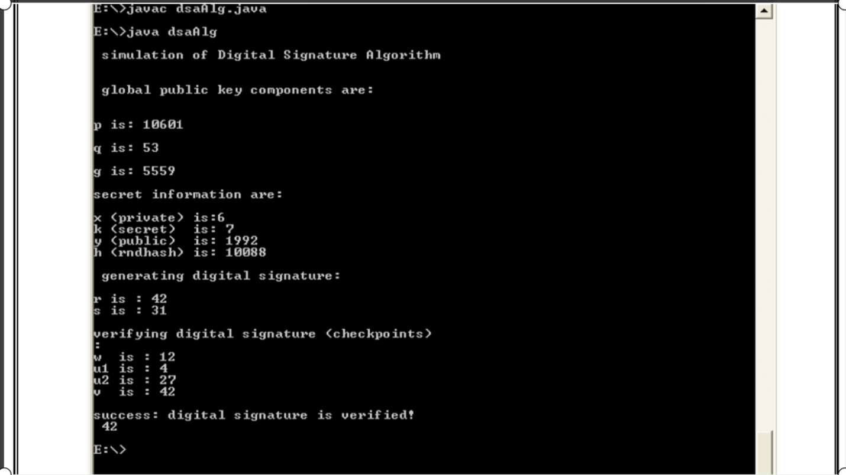

**RESULT:**

Thus the simple Code Optimization techniques had been implemented successfully.

**EX. NO: 04**

**SECURE DATA STORAGE, SECURE DATA TRANSMISSION AND FOR CREATING**

**DIGITAL SIGNATURES (GNUPG).**

**AIM:**

Demonstrate how to provide secure data storage, secure data transmission and for creating digital signatures (GnuPG).

**INTRODUCTION:**

1.Everyone can use GPG4WIN and its modules to encrypt e-mails and files;

2. GPG4WIN is compatible with other software that conform with OpenPGP

Standard**.**

**INSTALLING THE SOFTWARE**

1. Visit www.gpg4win.org   
    (or)  
    <https://www.techspot.com/downloads/6650-gpg4win.html>  
    (or)   
    <https://www.gpg4win.org/change-history.html>
2. The installation process will tell you when it is complete.
3. The Gpg4win setup wizard is complete.
4. If you do not uncheck the “Show the README file” check box, the README file will be displayed. The window can be closed after you’ve reviewed it.

**CREATING YOUR PUBLIC AND PRIVATE KEYS**

1. GPG encryption and decryption is based upon the keys of the person who will be receiving the encrypted file or message.
2. Any individual who wants to send the person an encrypted file or message must possess the recipient’s public key certificate to encrypt the message. The recipient must have the associated private key, which is different than the public key, to be able to decrypt the file.
3. The public and private key pair for an individual is usually generated by the individual on his or her computer using the installed GPG program, called “Kleopatra”.

**Procedure:**

1. From your start bar, select the “Kleopatra” icon to start the Kleopatra certificate management software

2. The following screen will be displayed

3. From the “File” dropdown, click on the “New Certificate” option

4. The following screen will be displayed. Click on “Create a personal OpenGPG key pair” and the “Next” button

5. The Certificate Creation Wizard will start and display the following Attributes.

6. Enter your name and e-mail address. You may also enter an optional comment. Then, click the “Next” button

7. Review your entered values. If OK, click the “Create Key” button

8. You will be asked to enter a passphrase

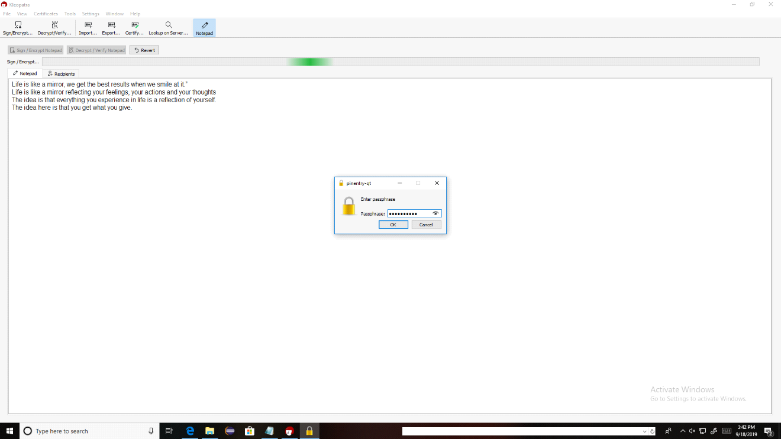

9. The passphrase should follow strong password standards. After you’ve entered your passphrase, click the “OK” button.

10. You will be asked to re-enter the passphrase

11. Re-enter the passphrase value. Then click the “OK” button. If the passphrases match, the certificate will be created.

**DECRYPTING AN ENCRYPTED E-MAIL THAT HAS BEEN SENT TO YOU:**

1. Open the e-mail message

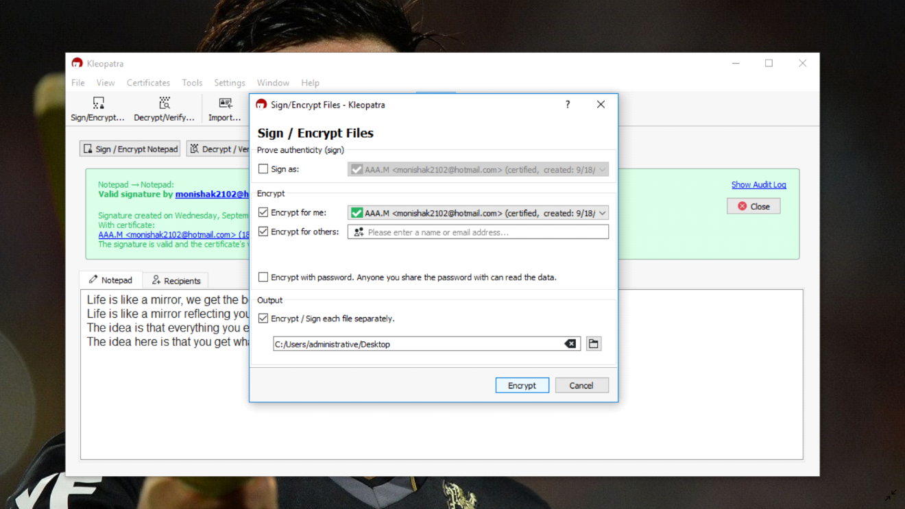

2.A command window will open along with a window that asks for the Passphrase to your private key that will be used to decrypt the incoming message.

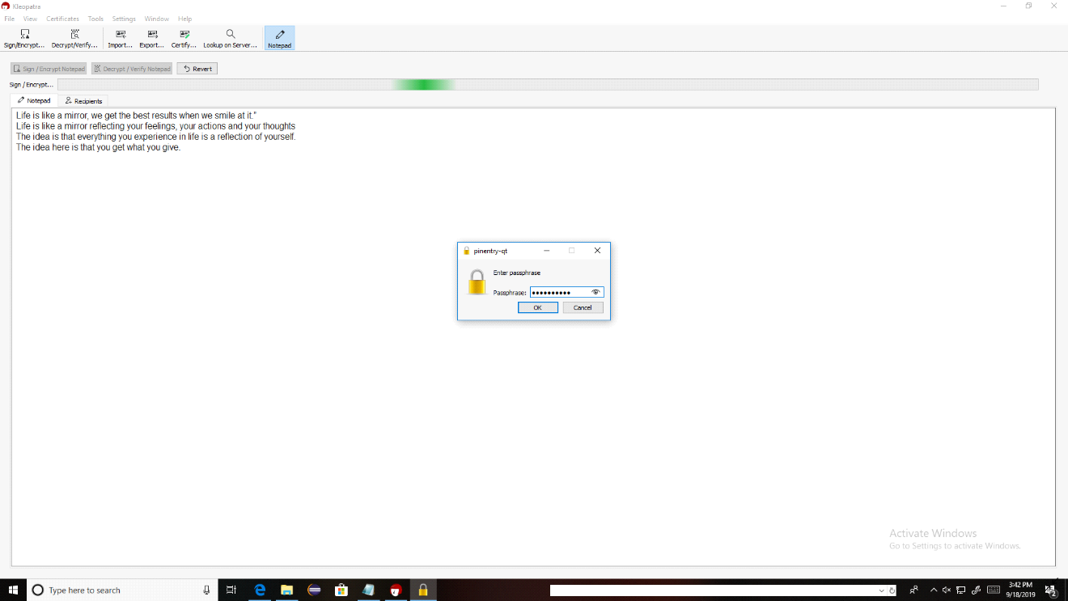

3. Re -Enter your passphrase and click the “OK” button

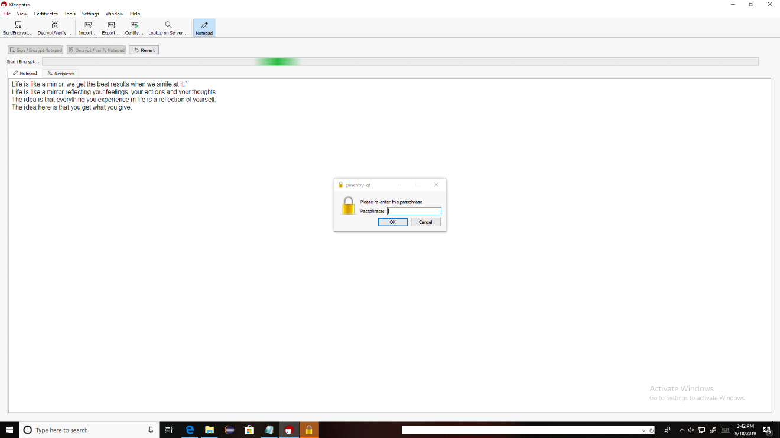

4.Your unencrypted e-mail message body will be displayed.

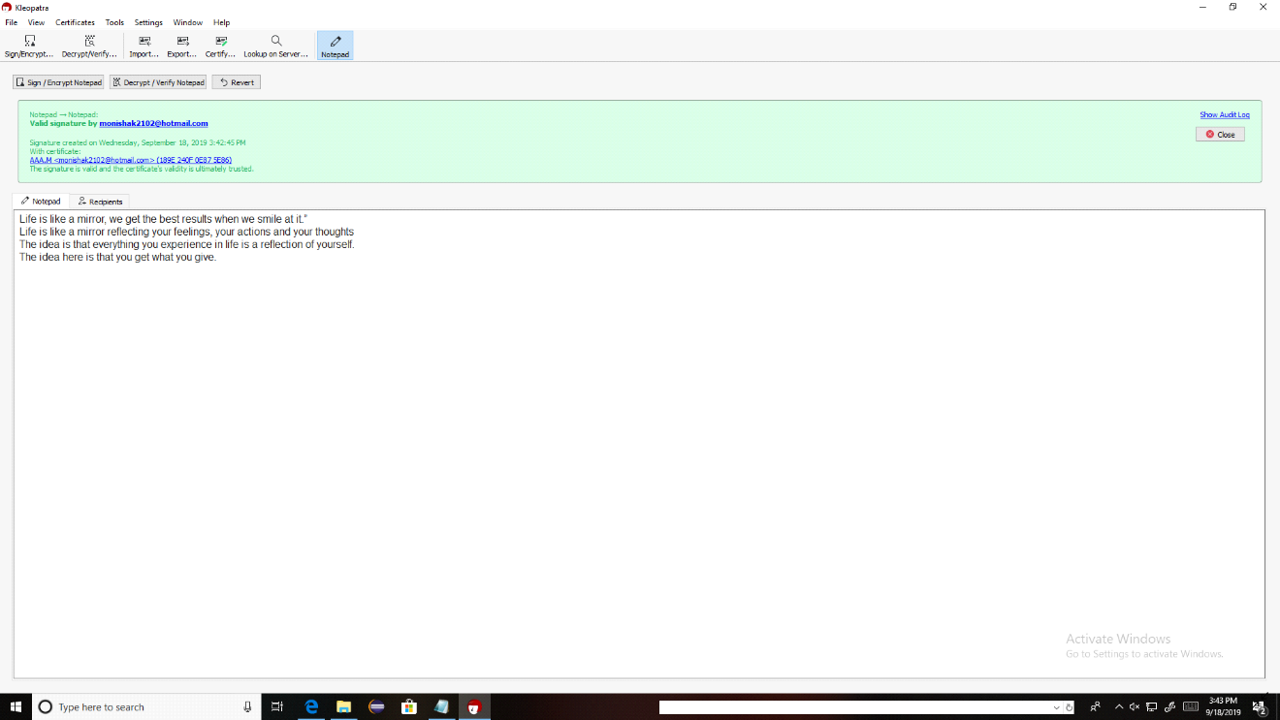

5. When you close the e-mail you will be asked if you want to save the e-mail message in its unencrypted form. For maximum security, click the “No” button. This will keep the message encrypted within the e-mail system and will require you to enter your passphrase each time you reopen the e-mail message

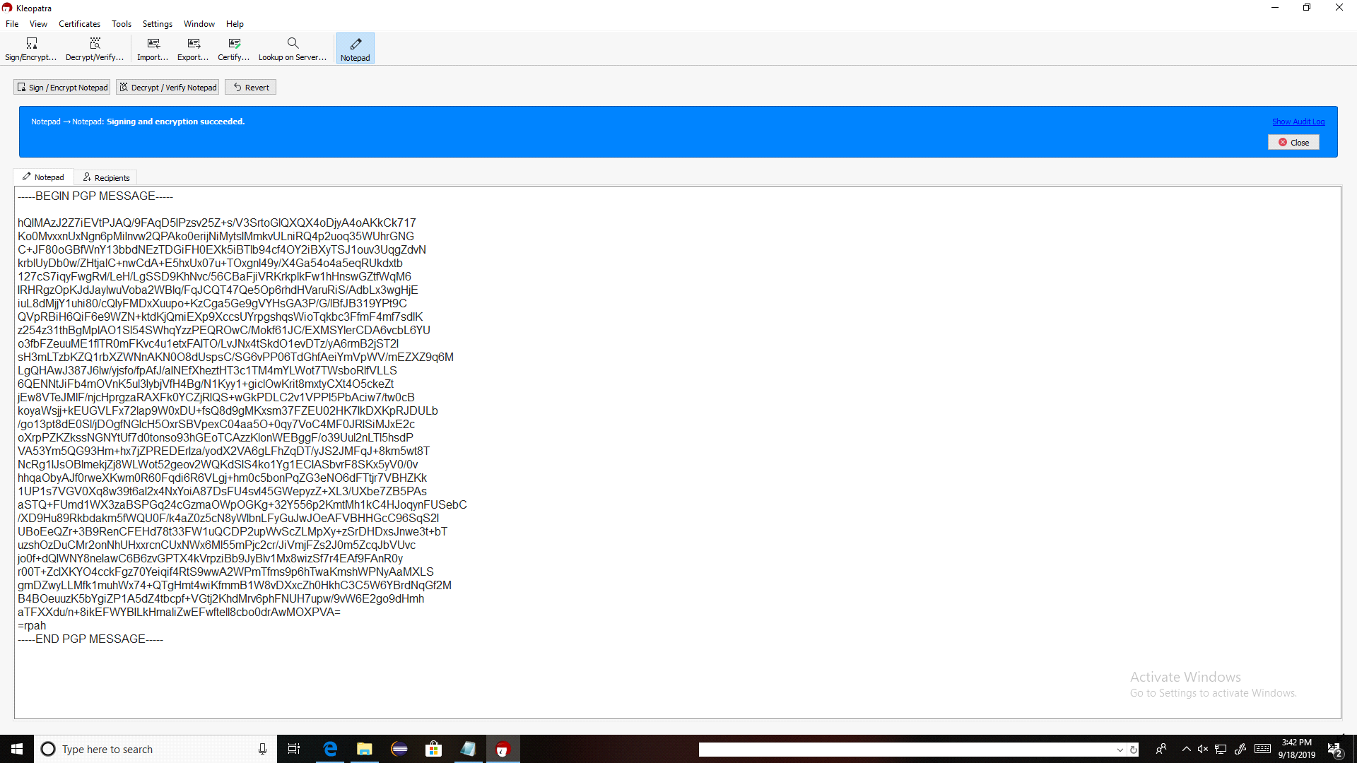

6.And next you click the decrypt button. again you will be enter the password Your unencrypted e-mail message body will be displayed.

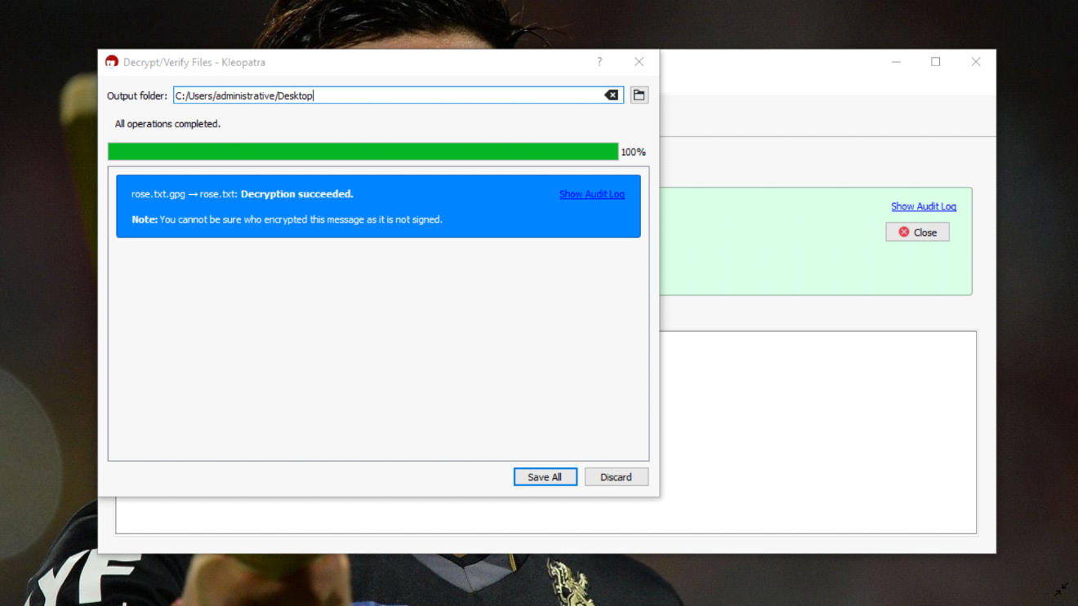



**RESULT:**

Thus the secure data storage, secure data transmission and for creating digital signatures (GnuPG) was developed successfully.

**EX:NO:5**

**SETUP A HONEY POT AND MONITOR THE HONEYPOT ON NETWORK (KF SENSOR)**

**Aim:**

To setup a honey pot and monitor the honeypot on network using kf sensor.

**Introduction:**

**Honeypot:**

Honey Pot is a device placed on Computer Network specifically designed to capture malicious network traffic.

* **KF Sensor:**
  + Windows based honeypot known as KF Sensor
  + KF Sensor is the tool to setup as honeypot when KF Sensor is running it places a siren icon in the windows system tray in the bottom right of the screen.
  + If there are no alerts then green icon is displayed.
  + It detects an incoming attack or port scanning and reports it to you.

**WinPcap:**

WinPcap has been recognized as the industry-standard tool for link-layer network access in Windows environments, allowing applications to capture and transmit network packets bypassing the protocol stack, and including kernel-level packet filtering, a network statistics engine and support for remote packet capture.

**Components:**

1. **KF Sensor server :**
   * KF Sensor Server Performs core functionality
   * It listens to both TCP and UDP ports on the server machine and interacts with visitors and generates events.
   * A daemon that runs at the background (like Unix daemon)
2. **KF Sensor Monitor :**

* It Interprets all the data and alerts captured by server in graphical form.
* Using it you can configure the KF Sensor Server and monitor the events generated by the KF Sensor Server

**Procedure:**

1. Download and install winpcap from the given link and install it.

<https://www.winpcap.org/install/default.htm>

1. Download KF Sensor Evaluation Setup File from KF Sensor Website.

<http://www.keyfocus.net/kfsensor/free-trial/>

1. Install with License Agreement and appropriate directory path and Click Finish.
2. Now KF sensor Honeypot is ready to running on the network host.
3. Navigate Start -> All Programs -> KF Sensor
4. Then Right click on KF Sensor icon and select “ Run as Administrator”

The KF Sensor Monitor will be appears look like below.

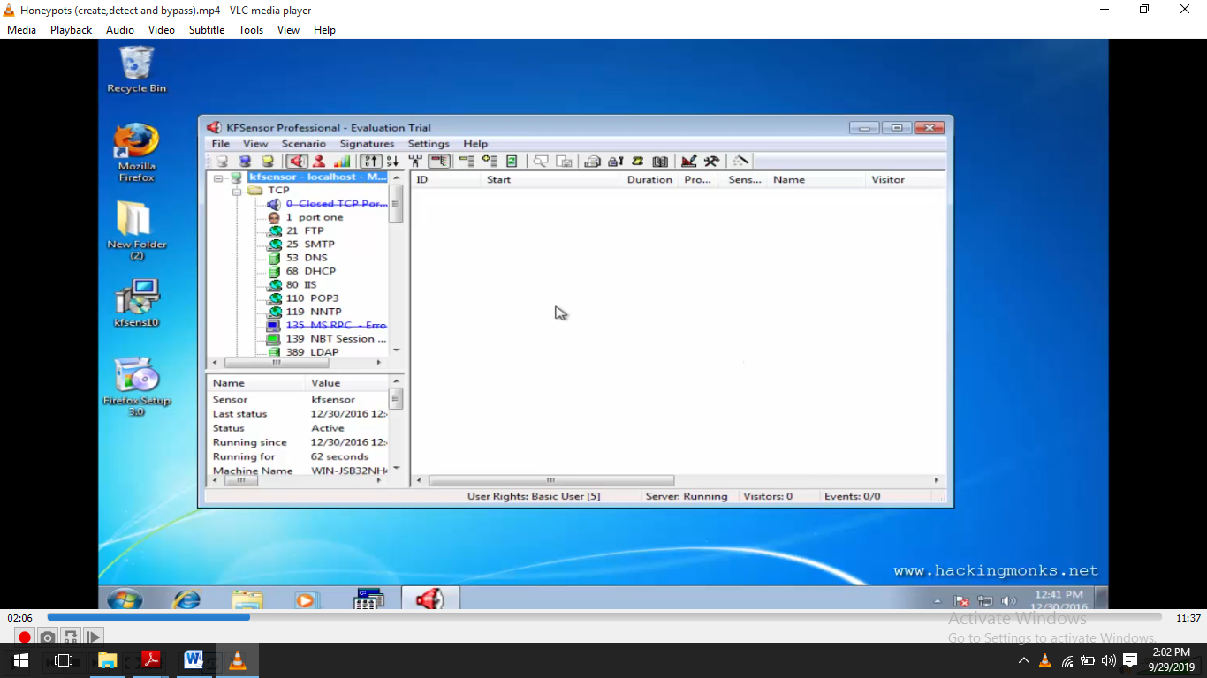Now Find IP address of the Honeypot system using “ipconfig” command through cmd.

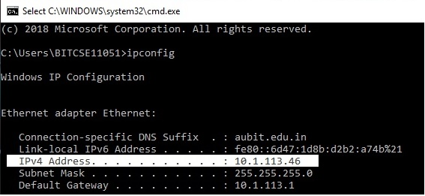

1. Now any other system on the network will try to ping the Honeypot system using ping command in cmd.

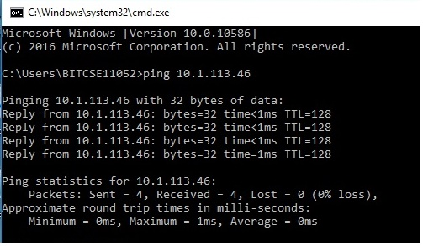

1. At the same time the Honeypot system automatically alerting by Siren signal
2. Then it will display the attack details look like below

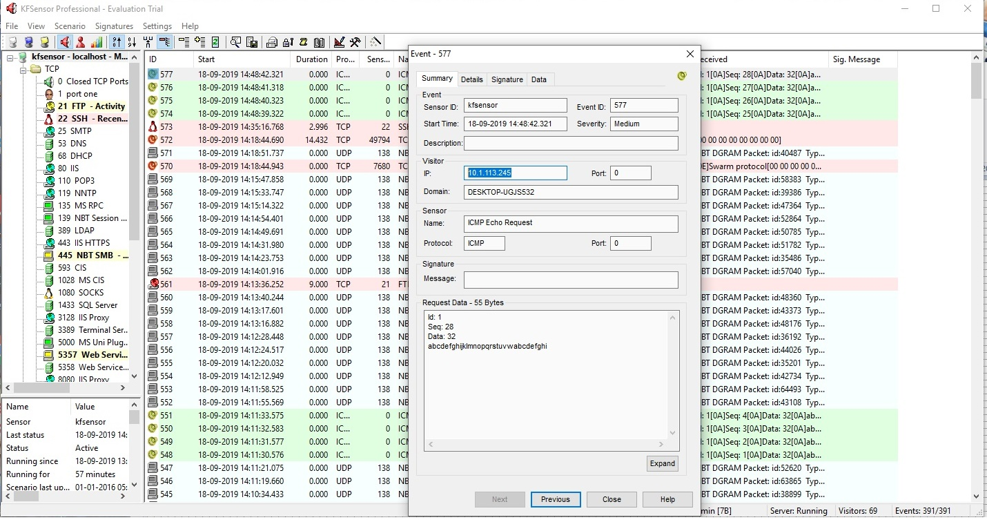

10.Select and open any one of the activity and it shows the details about Intruders (eg. IP address ,type of attack , conetents of the attack.etc)



**Simulation of DoS Attack :**

1. click Settings-> DoS Attack settings and reduce the values in the Dos Attack Settings Tab.

2. Then at any System open the cmd and type the following command.

**ping ipaddress -t**

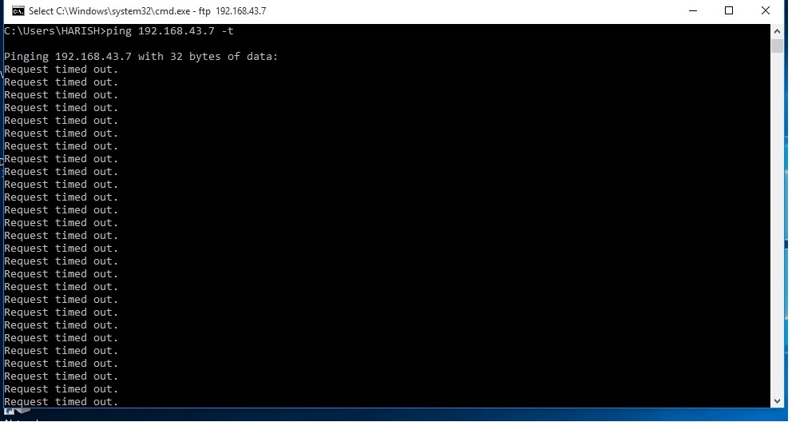

At the same time the Honeypot System alerts look like.

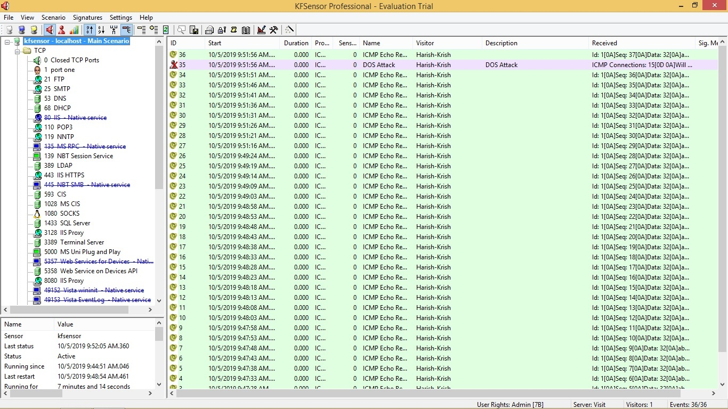

Click the event to knoe about the attacke details and attacker ip address.

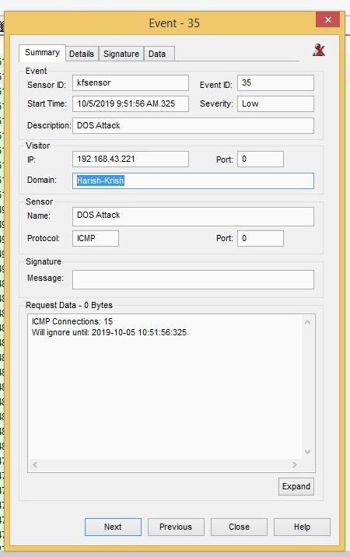

**Simulation of**  **Telnet:**

1.Open CMD and type the following command

**telnet ipaddress 25.**

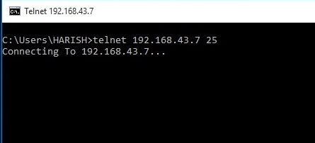

At immediately the Honeypot alerts the SMTP alert

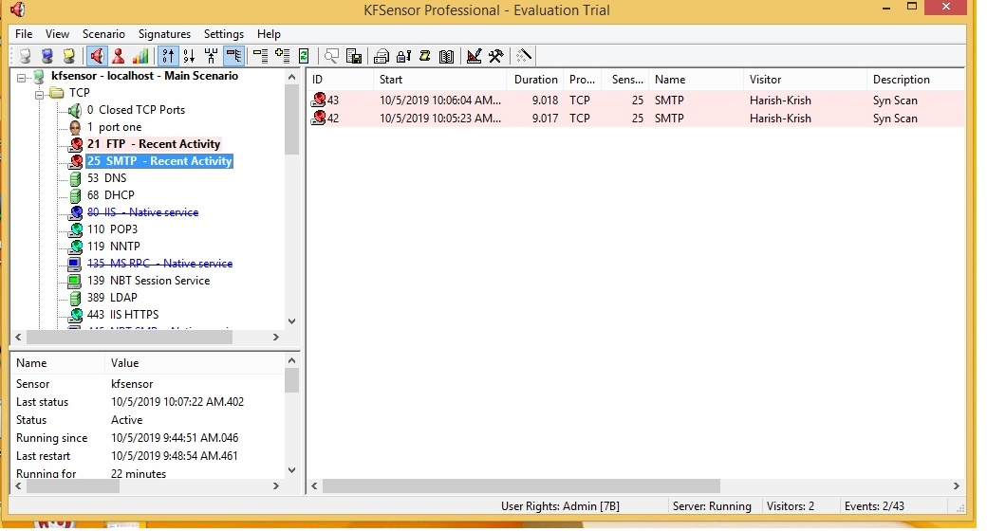

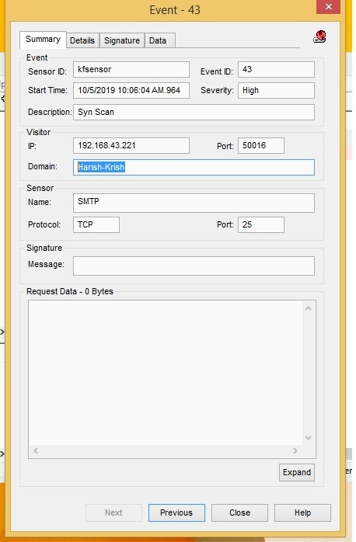

And double click the event to see the attacker details.

**Simulation of FTP:**

1.Open cmd and type

**ftp ipaddress**

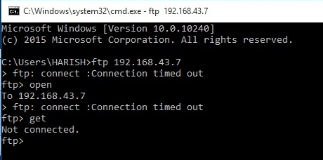

Immediately honeypot system alerts the FTP alert

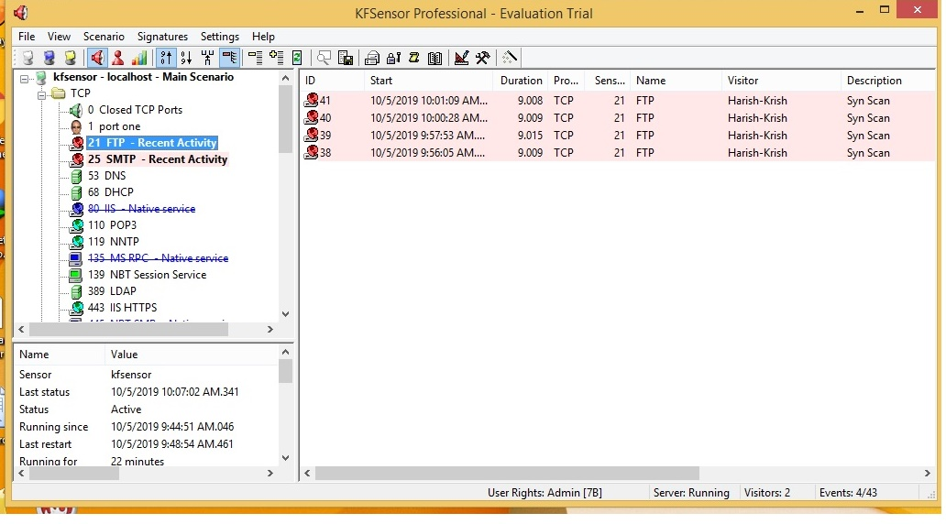

Click the event to see the details of the attacker details.

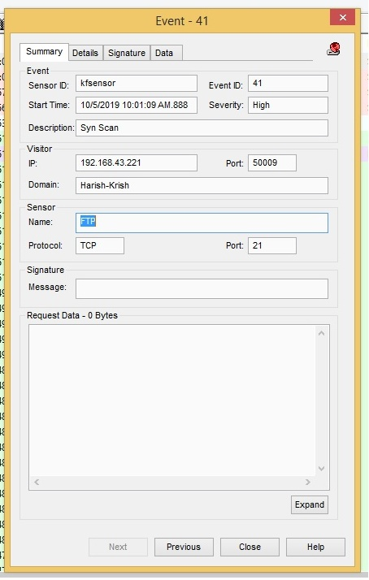

**Result:**

Thus the study of setup a hotspot and monitor the hotspot on network has been developed successfully.

**EX:NO:6**

**INSTALL ROOTKITS AND STUDY VARIETY OF OPTIONS**

**Aim:**

To install rootkits and study about the variety of options.

**Introduction**:

Rootkit is a stealth type of malicious software designed to hide the existence of certain process from normal methods of detection and enables continued privileged access to a computer

Root kit is a stealth type of malicious software designed to hide the existence of certain process from normal methods of detection and enables continued privileged access to a computer

**Options:**

**1.Processes:** This shows all running processes and it allows to kill any unwanted process if any.

**2.Modules**: This menu displays the various system files like .sys, .dll

**3.Services:** This menu displays the complete services running with Autostart, Enable, Disable, System, Boot.

**4.Files**: This menu displays full files on Hard-Disk volumes.

**5.Registry**: This menu displays Hkey_Current_user and Hkey_Local_Machine.

**6.Rootkits/Malawares:** This menu scans the local drives selected.

**7.Autostart**: This menu displays the registry base Autostart applications.

**8.CMD**: This menu allows the user to interact with command line utilities or Registry.

**Procedure:**

1. Download Rootkit Tool from GMER website.

[www.gmer.net](http://www.gmer.net)

1. Install the software and after installing it will appears below.

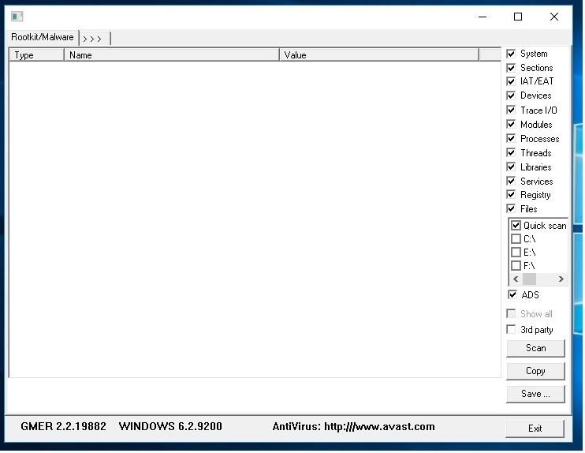

3.if we select processes menu ,it will appears like below.

🡪You can kill any process if you want.

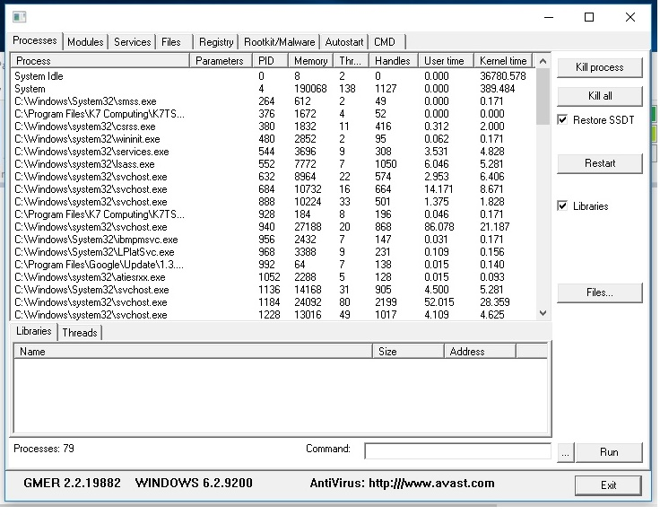

4.If we select the Modules menu it look like below.

* It will shows the list of .dll and .sys files.If you want to see the information about that files then simply double click it.

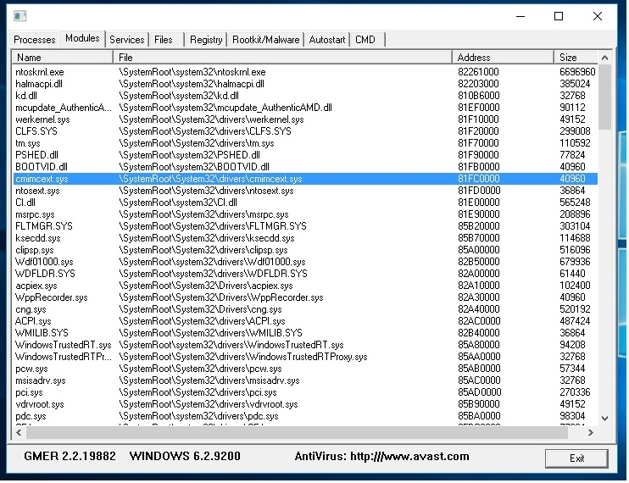

5.if we select the Services menu it will appears look like below.

🡪It will shows the list of services. If you want to see the information about that services then simply double click it.

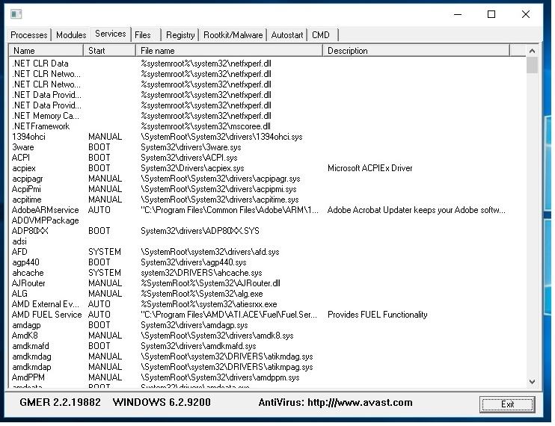

6.if we select the Files menu it will look like below

🡪 it allows to see the hard disk partitions ,folders and files in the system.

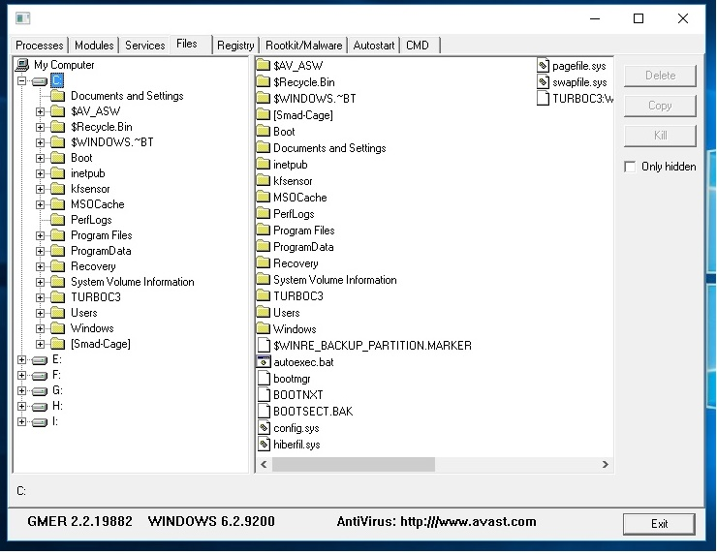

7. if we select the Registry menu it will look like below

🡪 It shows the Registry files in the selected folder.

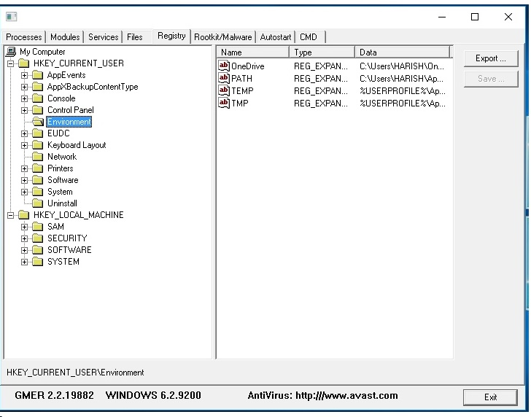

8. if we select the Rootkit/Malware menu it will look like below.

* It allows to scan the system whether any Rootkit/Malware in the selected partitions.

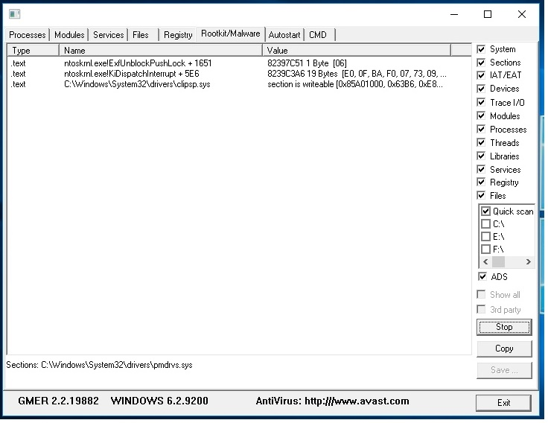

9. if we select the Autostart menu it will look like below

🡪 it scans the Auto Start services during the system boot and displays them.

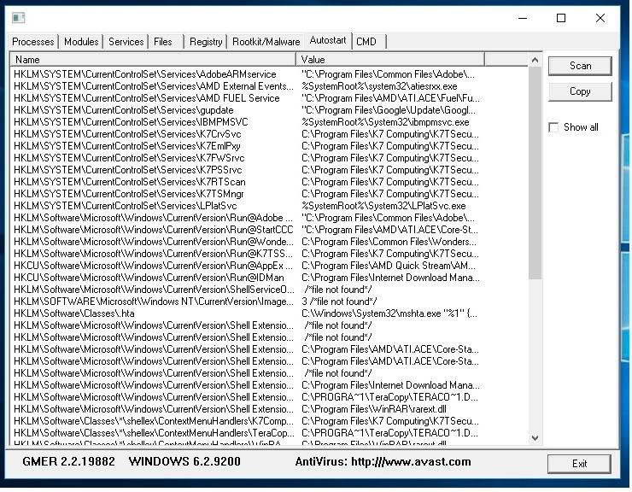

10. if we select the Files menu it will look like below

🡪If we type any command in the upper side terminal and click Run button then it will shows the result of the command in the bottom log .

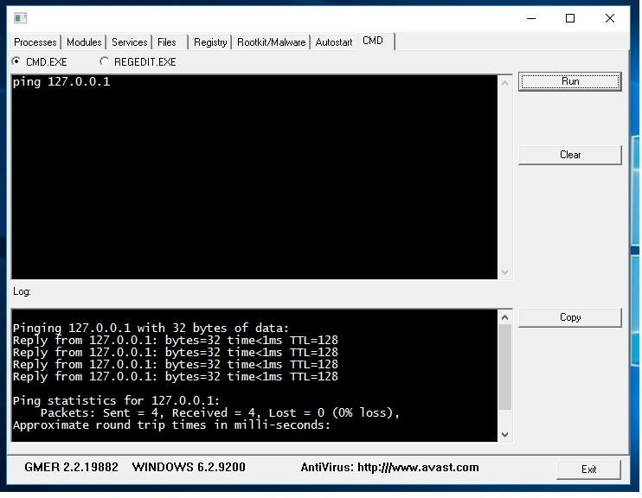

**Result:**

Thus the Rootkits are successfully installed and its variety of options has been studied

**EX:NO:7**

**PERFORM WIRELESS AUDIT ON AN ACCESS POINT OR A ROUTER AND DECRYPT WEP AND WPA**

**AIM:**

To perform wireless Audit on an Access point or A router and Decrypt WEP and WPA.(ViStumbler).

**Introduction:**

ViStumbler aircrack on ubuntu is a tool for windows that facilitates detection of Wireless LANs using the 802.11b, 802.11a and 802.11g WLAN standards. It is one of the Wi-Fi hacking tool which only compatible with windows; this tool also a freeware.

**DESCRIPTION :**

* + - 1. ViStumbler is one of the Wi-Fi hacking tool which only compatible with windows, this tool also a freeware.
      2. With this program, we can search for wireless network which open and infiltrate the network.

🡪Download and install ViStumbler

* + - 1. Now Run ViStumbler and click Scan Ap’s.
      2. It will Shows the Wireless AP’s and their Details which are nearly in the System.
      3. There are several indicators regarding the strength of the signal, such as GREEN indicates Strong, YELLOW and other color indicates a weaker signal, RED indicates a very weak and GREY indicates a signal loss.
      4. Lock symbol with GREEN bubble indicates the Access point has encryption enabled.
      5. MAC assigned to Wireless Access Point is displayed on right hand pane.
      6. The next column displays the Access points Service Set Identifier[SSID] which is useful to crack the password.
      7. Select any AP and click Graph1 or Graph 2 to see the transfer rate of the AP in the two types of Grpahical form.

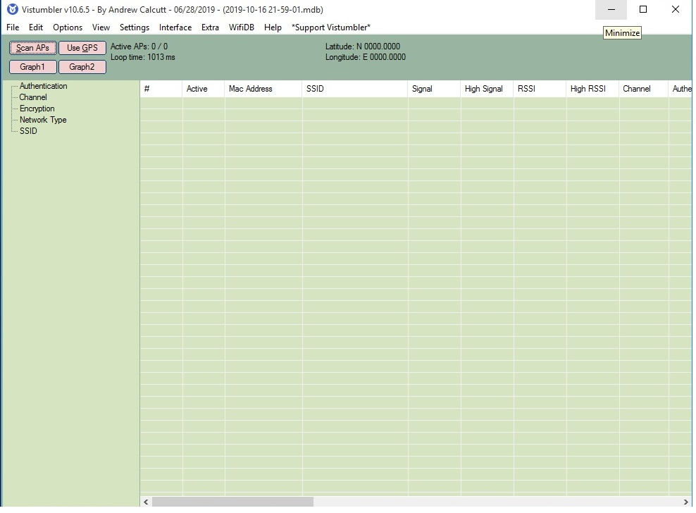

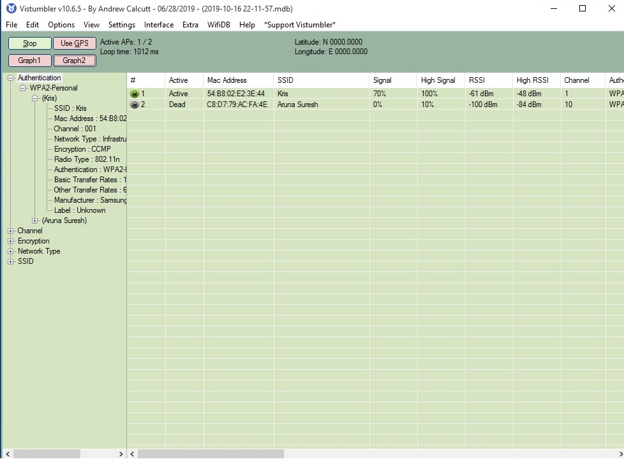

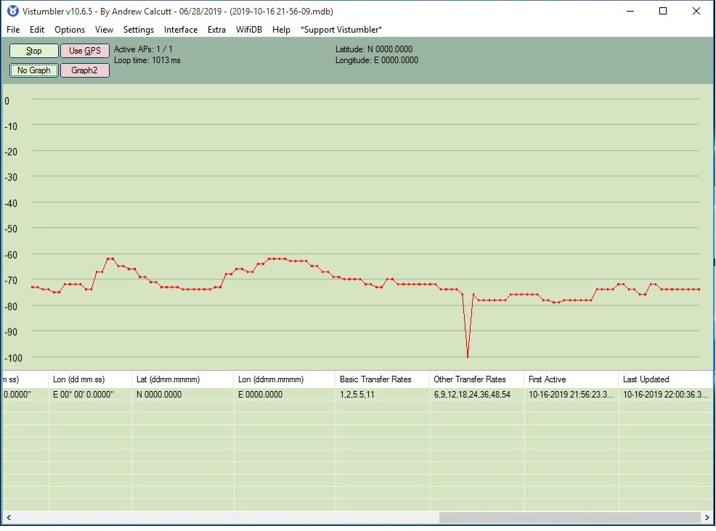

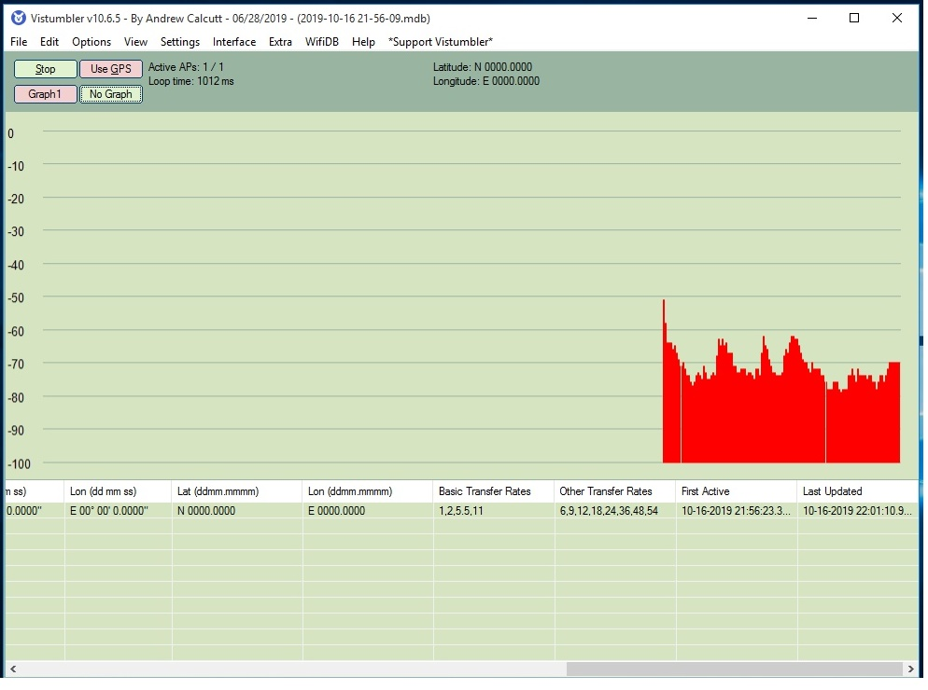

**RESULT:**

thus the wireless audit on an access point or a router has been demonstrated successfully.

**EX:NO:8**

**DEMONSTRATE INTRUSION DETECTION SYSTEM (IDS) USING SNORT TOOL**

**Aim:**

To demonstrate intrusion detection system using snort tool in packet sniffer mode.

**INTRODUCTION:**

**INTRUSION DETECTION SYSTEM :**

Intrusion detection is a set of techniques and methods that are used to detect suspicious activity both at the network and host level.

**SNORT TOOL:**

* 1. Snort is an open source network intrusion detection system (NIDS) and it is a packet sniffer that monitors network traffic in real time
  2. Snort is based on libpcap (for library packet capture), a tool that is widely used in TCP/IPtraffic sniffers and analyzers.
  3. Through protocolanalysis and content searching and

matching, Snort detects attack methods, including denial of service, buffer overflow, CGI attacks, stealthport scans, and SMB probes.

* 1. When suspicious behavior is detected, Snort

sends a real-time alert to syslog, a separate 'alerts' file, or to apop-up window

` e.So Snort is currently the most popular free network intrusion detection software.

**Sniffer mode:**

**Command: Snort –v**

Print out the TCP/IP packets header on the screen

**Procedure:**

1. Download the following files from the webpages.
   * WinPcap: <WinPcap_4_1_3.exe>
   * Snort: <Snort_2_9_8_2_installer.exe>
   * Snort rules: <snortrules-snapshot-2982.tar.gz>

2.Install the WinPcap.

3.Install the Snort.

4.Extract the “snortrules-snapshot-2982.tar.gz” file and move the folders into Snort Home Folder.

(i.e. C:\Snort)

5.Now we will configure the snort as a sniffer mode in the Windows machine

6.Go to the C:\Snort\etc.

7. Edit the “snort.conf” file using notepad editor or equivalent editor.

8. Set the network variables

🡺Change HOME_NET to your home network IP address range **your IP Address**/24

🡺 Change EXTERNAL_NET to !$HOME_NET

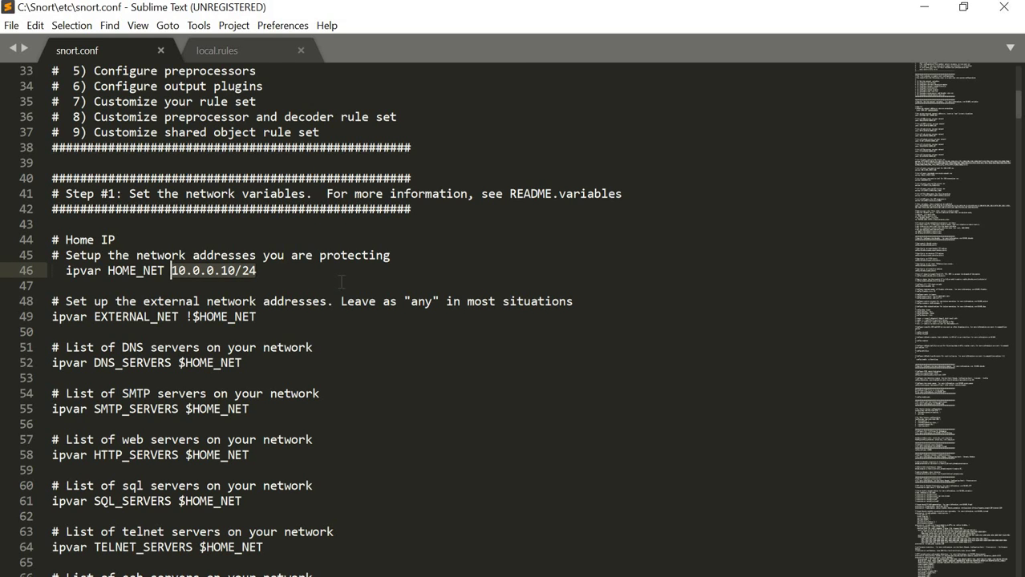

🡺. Change var RULE_PATH - actual path of rule files. i.e “c:\Snort\rules”

🡺Change var PREPROC_RULE_PATH - actual path of preprocessor rule files

i.e c:\Snort\preproc_rules

🡺 Comment ( put #)SO_RULE_PATH - as windows Snort doesn't use shared object rules

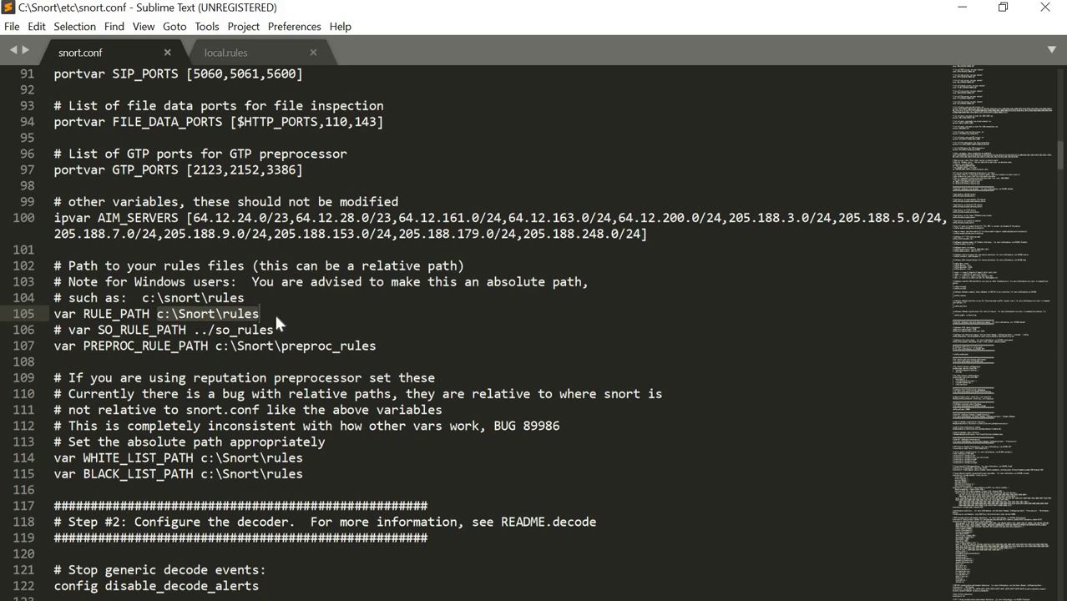

🡺 Configure trusted “white.list” file and untrusted “black.list>” - reputation preprocessor



9.Configure the decoder

🡺Set the default directory for Snort logs i.e. “c:\Snort\logs”

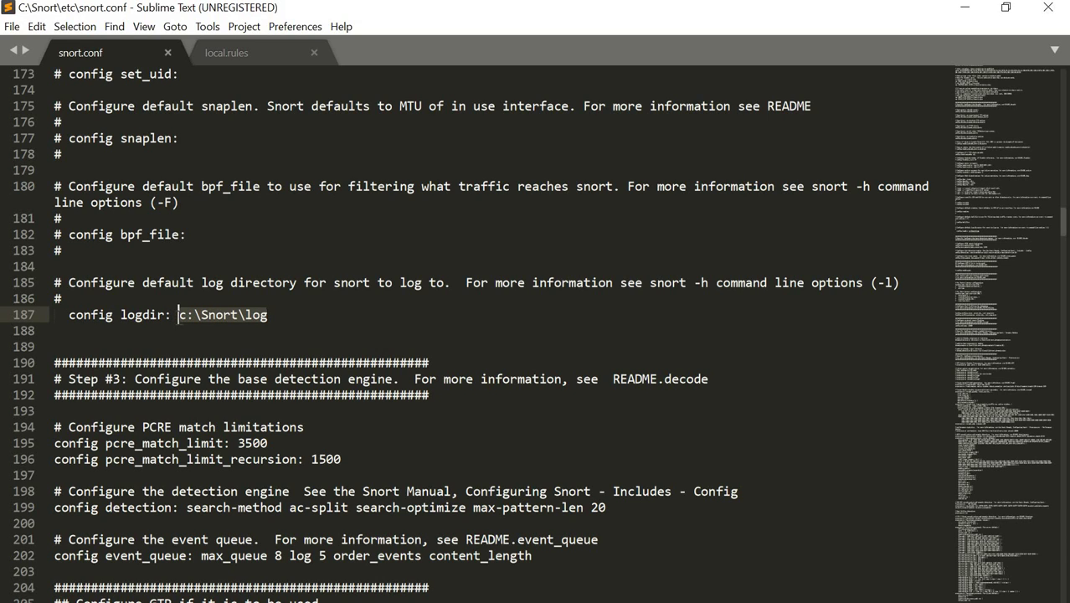

10. Configure dynamic loaded libraries

🡺. Change the dynamic loaded library path references

i.e. dynamicpreprocess direc “c:\Snort\lib\snort_dynamicpreprocessor”

i.e. dynamicengine direc “c:\Snort\lib\snort_dynamicengine\sf_engine.dll”

🡺 Remove the Comment dynamicdetection directory declaration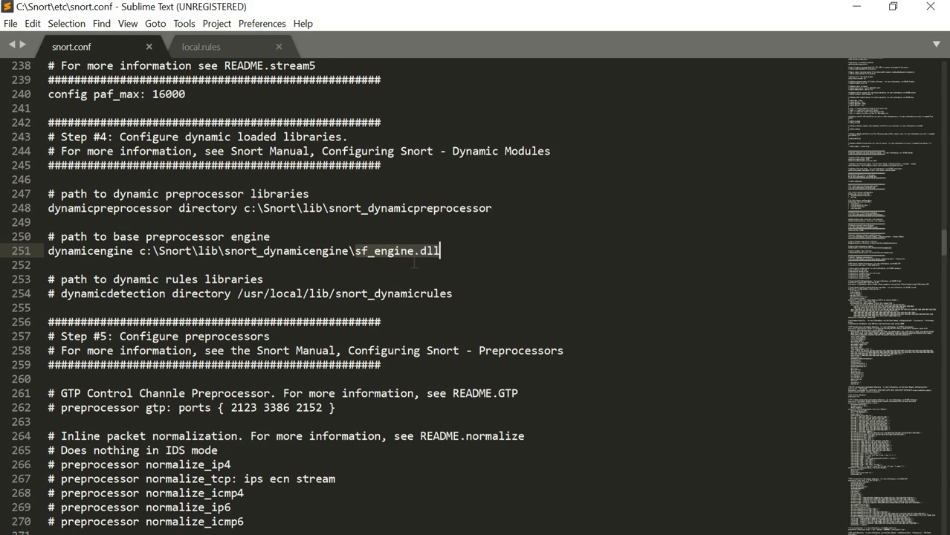

11. Configure preprocessors

Many Preprocessors are used by Snort - Check Snort manual before setting them.

🡺Comment on “inline packet normalization preprocessor”

This preprocessor is used when Snort is in-line IPS mode

🡺 For general purpose Snort usage - check these preprocessors are active

frag3

stream5

http_inpect

ftp_telnet

smtp

dns

ssl

sensitive_data

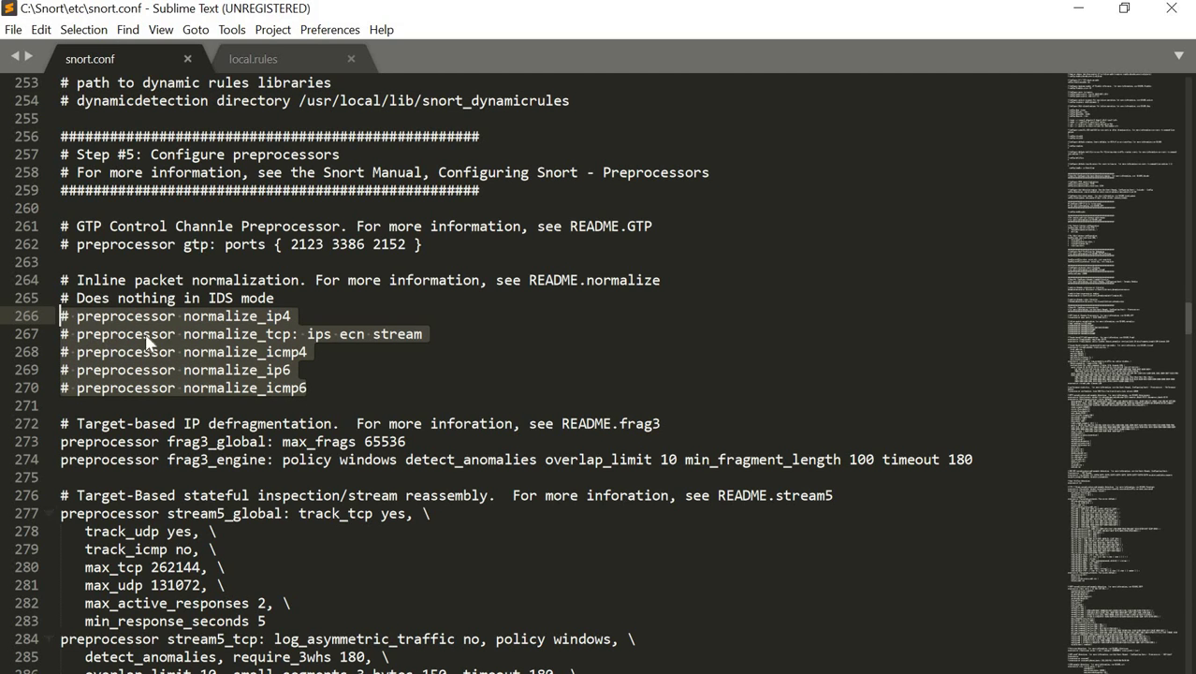

12. Comment the “ decompress_swf “ line.

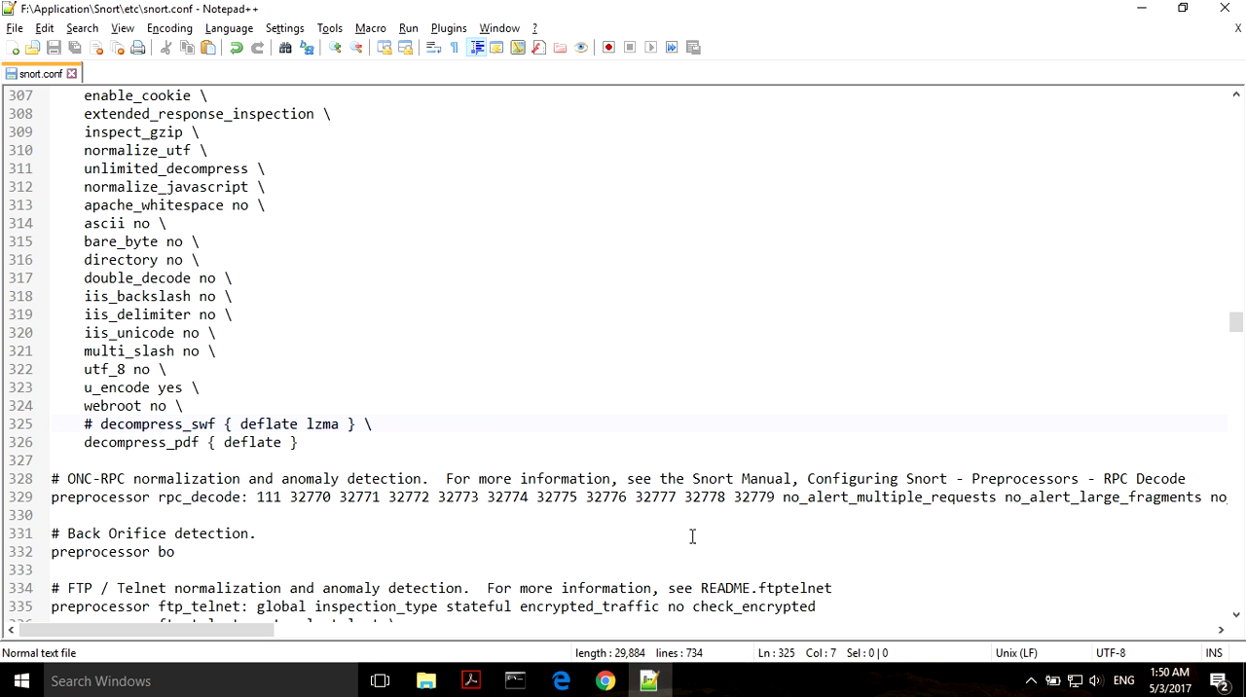

13. Remove the comment from “ preprocessor sfportscan “

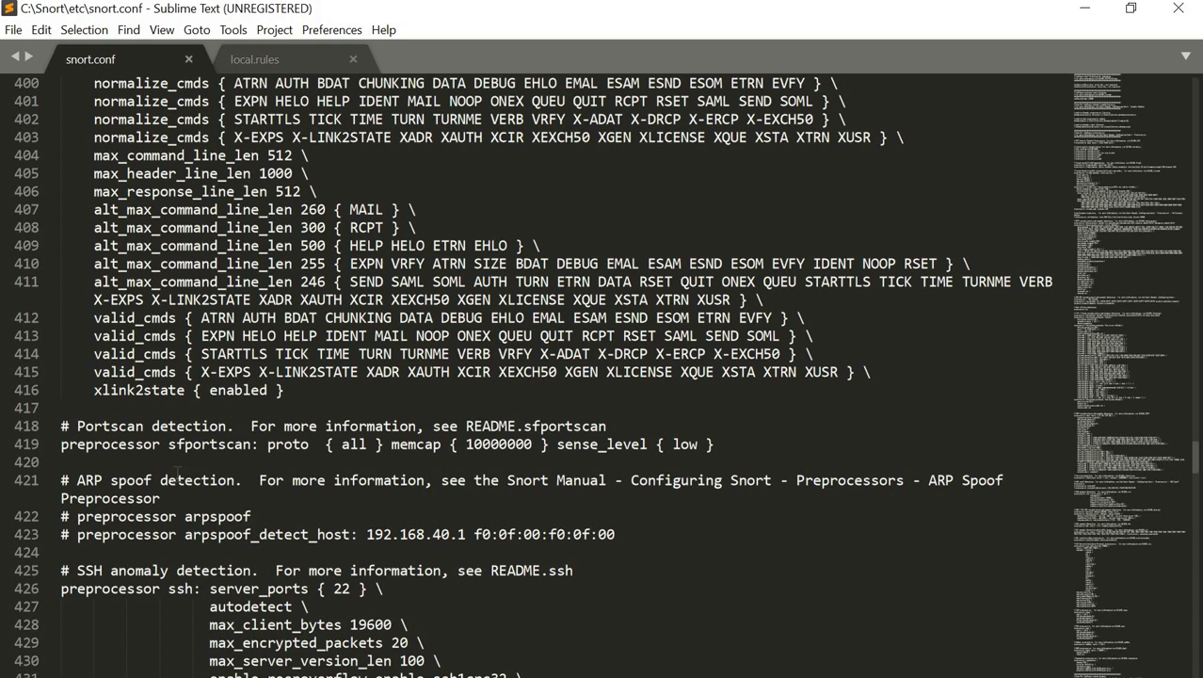

14. change the lines

🡺 whitelist $WHITE_LIST_PATH\white.list, \

blacklist $BLACK_LIST_PATH\black.list

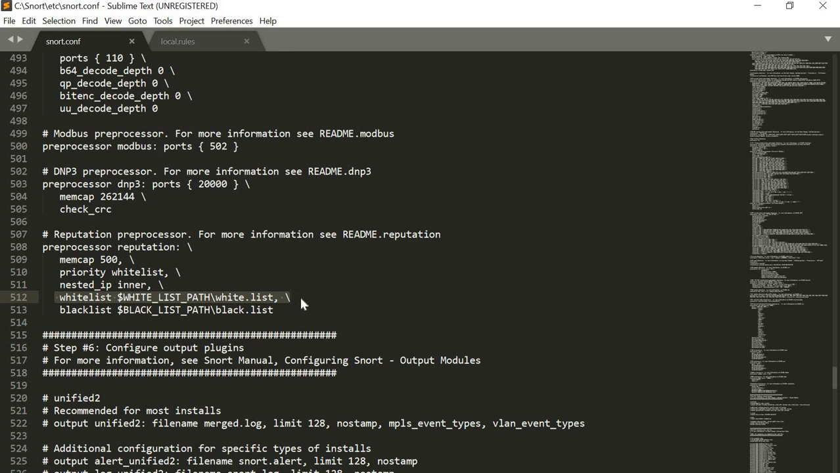

15. to create black.list file and white.list files

🡺open any Editor like Notepad++

🡺Type the following lines into the file.

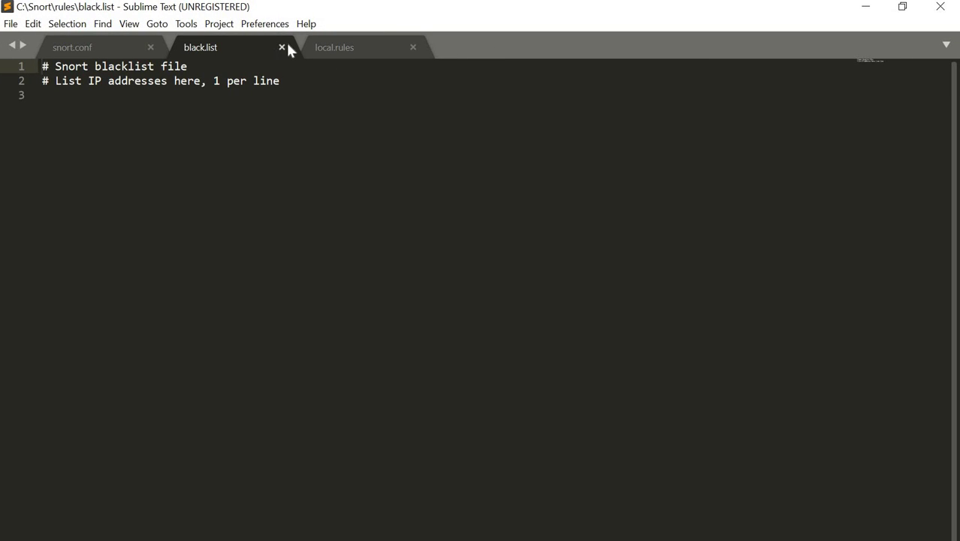

Then save this file in the location of “C:\Snort\rules” and the filename is “ black.list”.

🡺Do this same procedure once again for the “white.list” .

16.Customise your rule set

🡺 Uncomment “local.rules”

🡪 First time users, comment most of include statements.

🡪 Change the ‘/’ symbol to ‘\’ symbol.

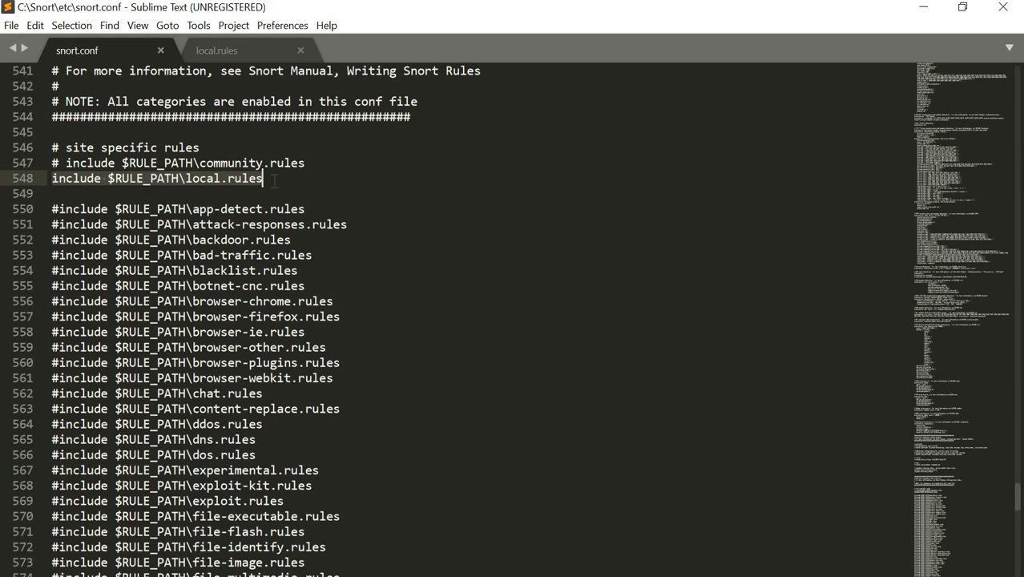

17.Customise preprocessor and decoder rule set

🡪 Uncomment the first two lines in Step 8

“include $PREPROC_RULE_PATH\preprocessor.rules”

“include $PREPROC_RULE_PATH\decoder.rules”

“include $PREPROC_RULE_PATH\sensitive-data.rules”

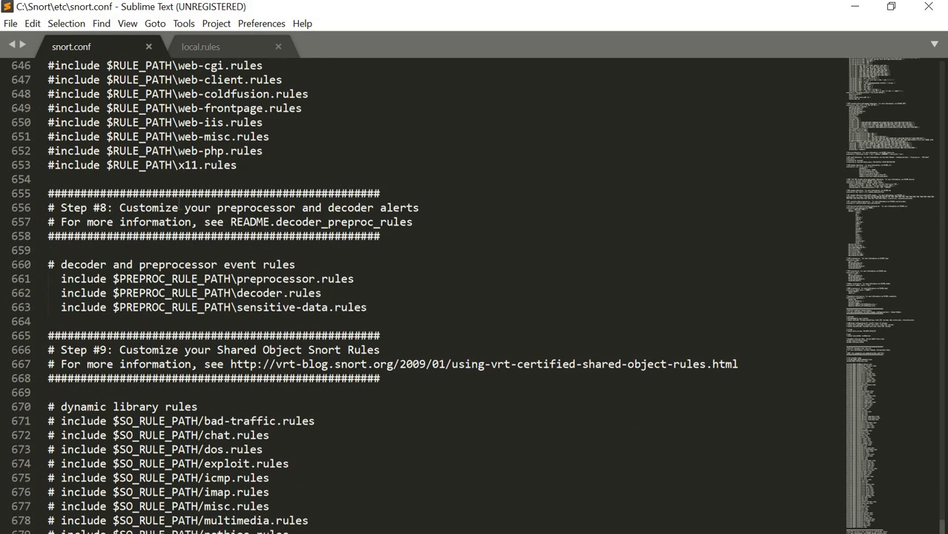

18.Now Save the snort.conf file.

19.Go to “C:\Snort\rules”and edit the “local.rules” file using notepad++.

20. Type the following and save the file.

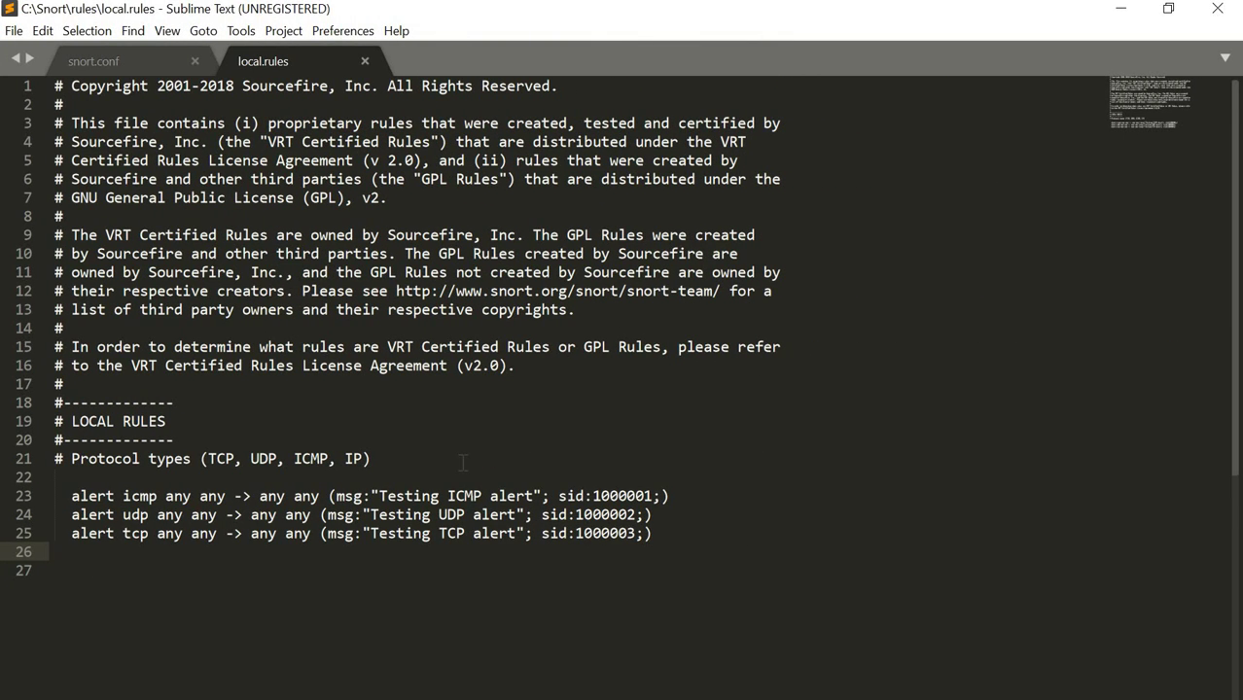

21. Open CMD and change the Snort folder as a Working Folder.

**Command: cd C:\Snort\bin**

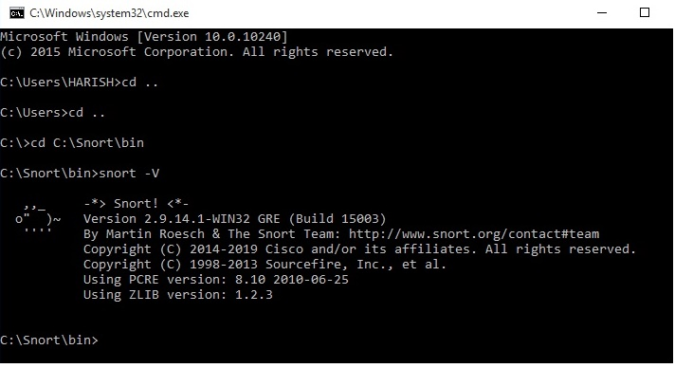

22. To check the installed version for Snort:

Command: snort -V



23. To check to see what network adapters are on your system

Command: snort -W

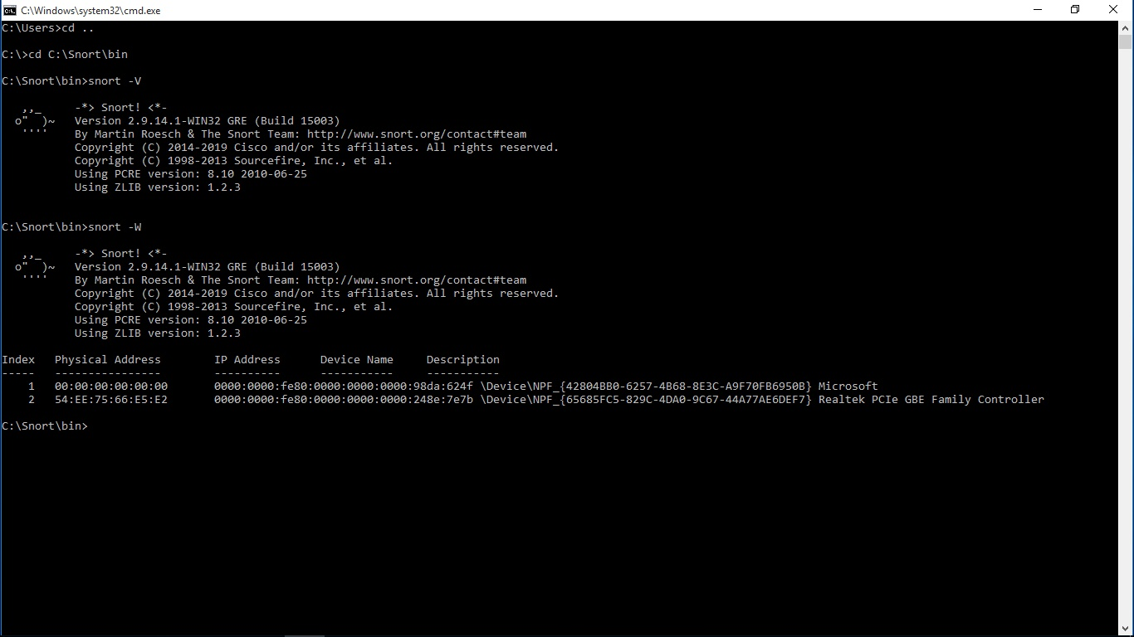

24. To Test the configuration and run the Snort as test mode.

Command: snort -i **<index>** -c C:\Snort\etc\snort.conf

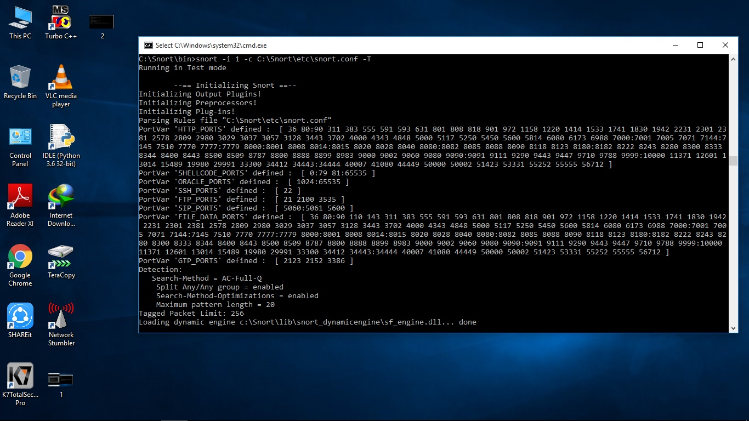

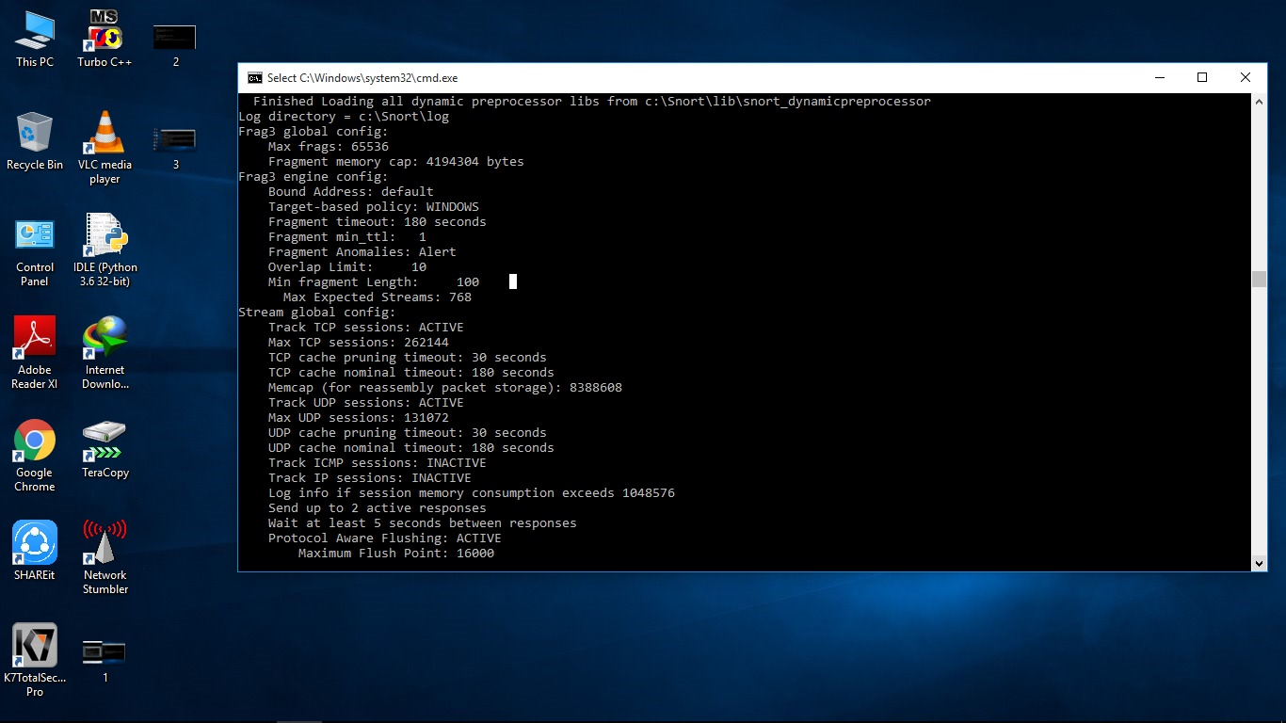

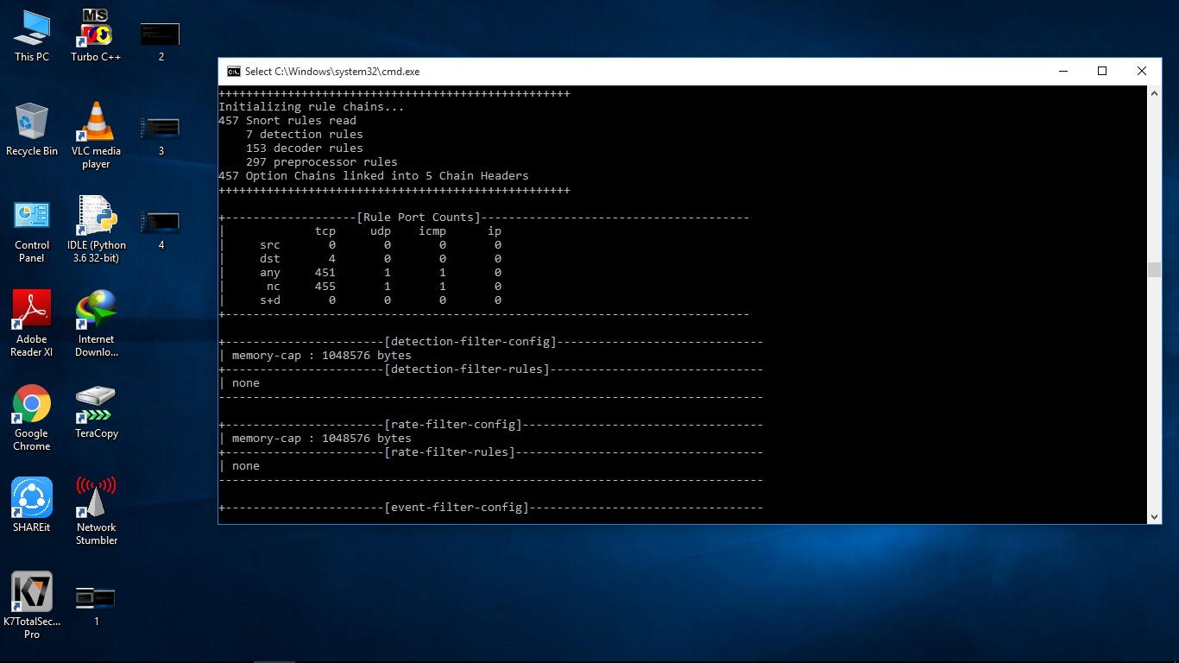

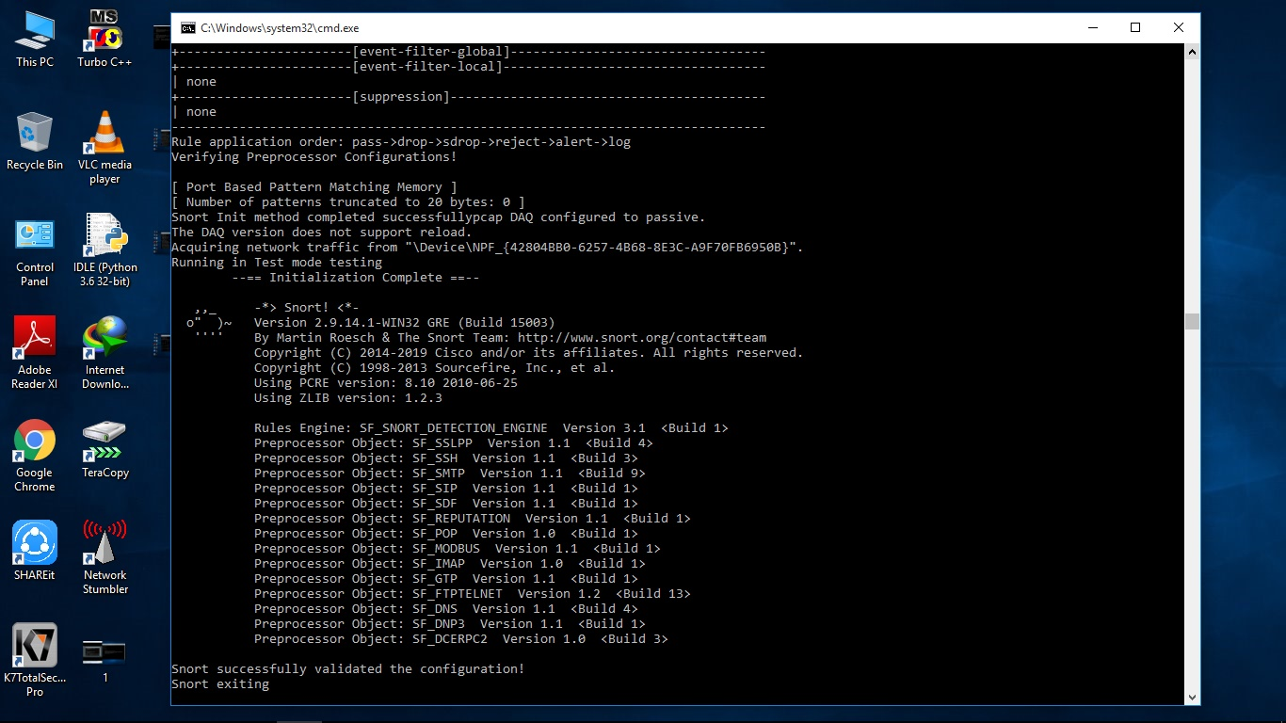

25: To Start the Snort

Command: snort -i <index> -c c:\Snort\etc\snort.conf -A console

Then snort automatically detects the network traffic via network analyzer (WinPcap) and displays the details about the traffic.

Open a web browser and browse to any web page You can see the alerts Snort produces and shows it in the terminal.

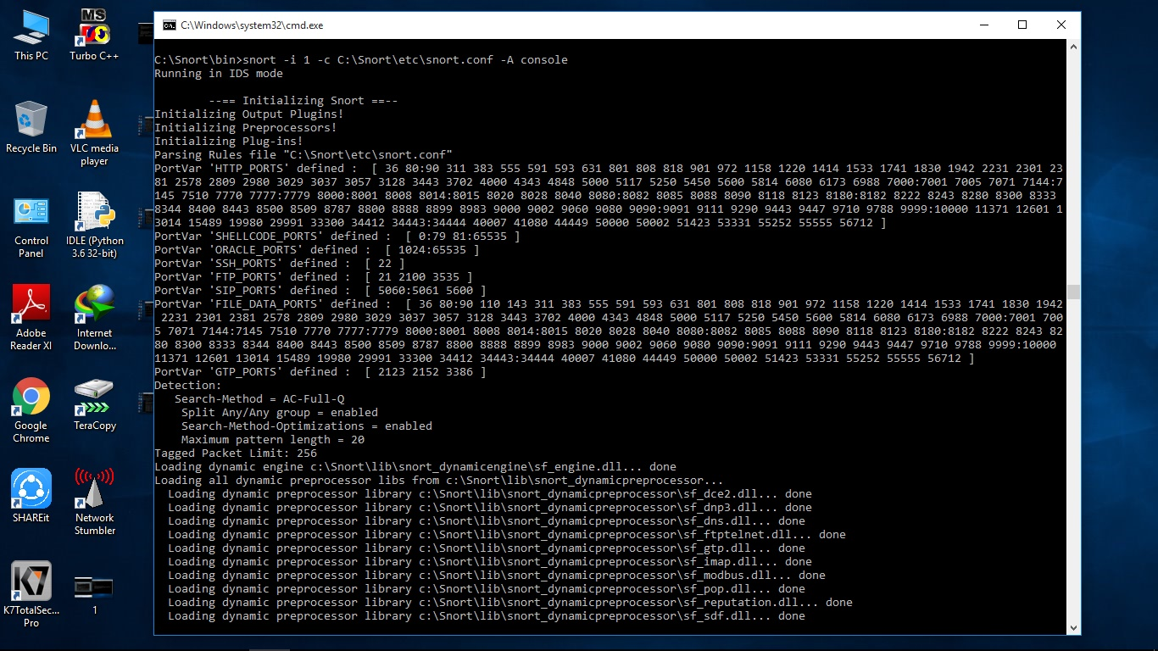

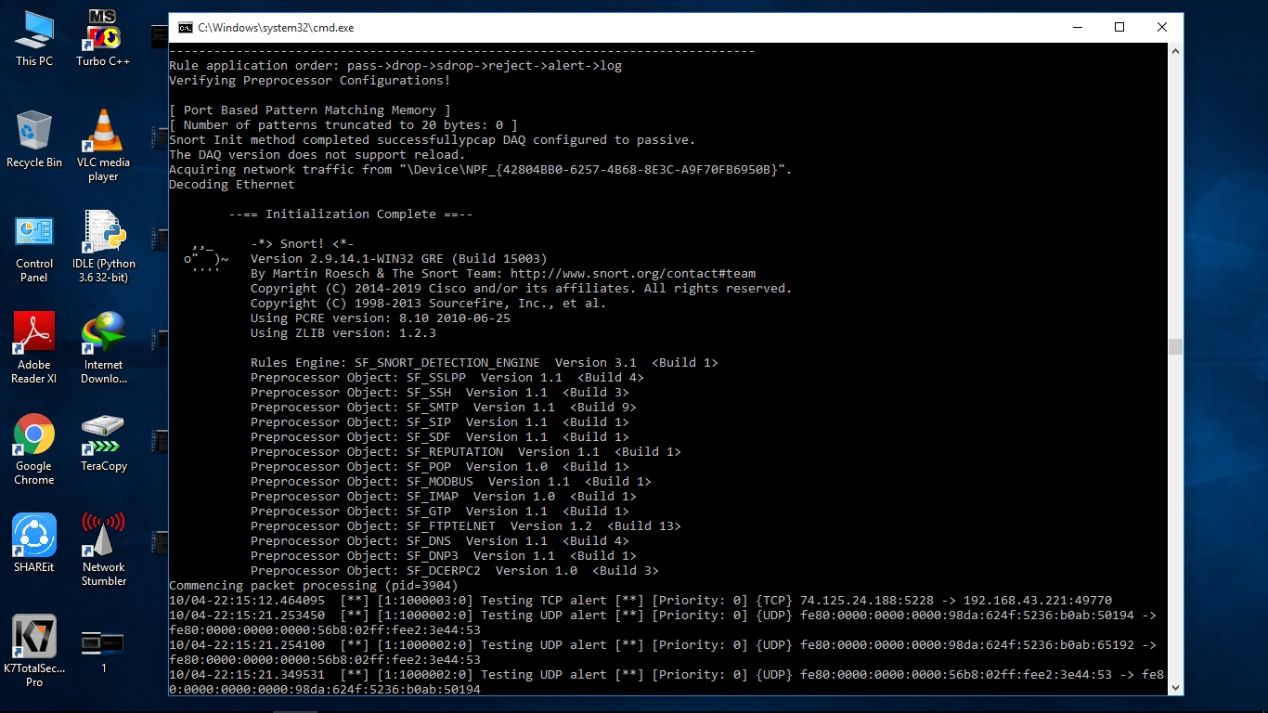

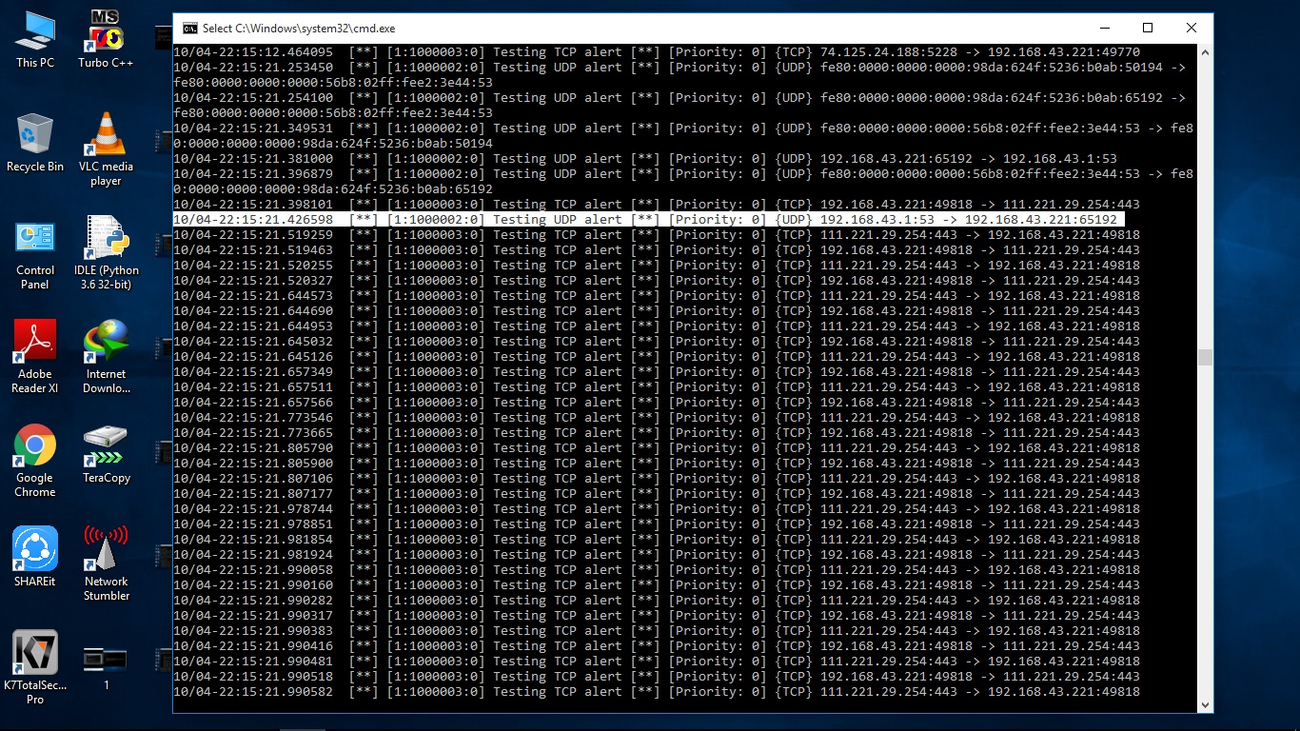

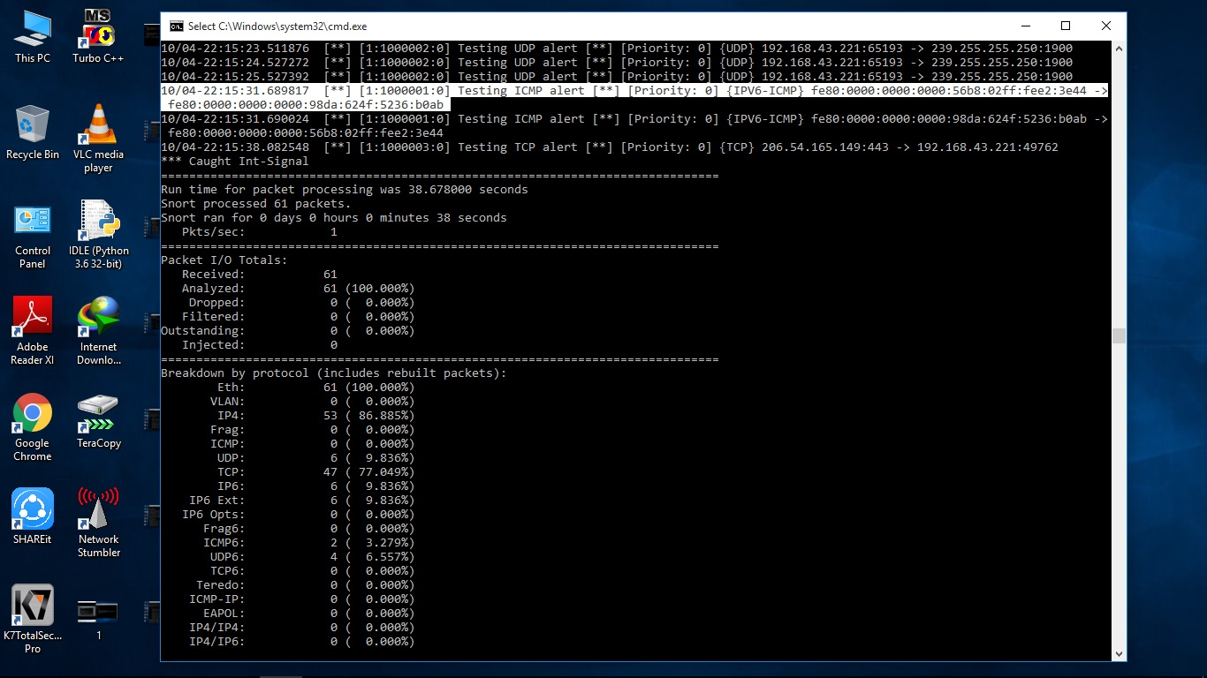

26 . To stop the Snort.

Press **CTRL+C** then it will stopped and gives the total report.



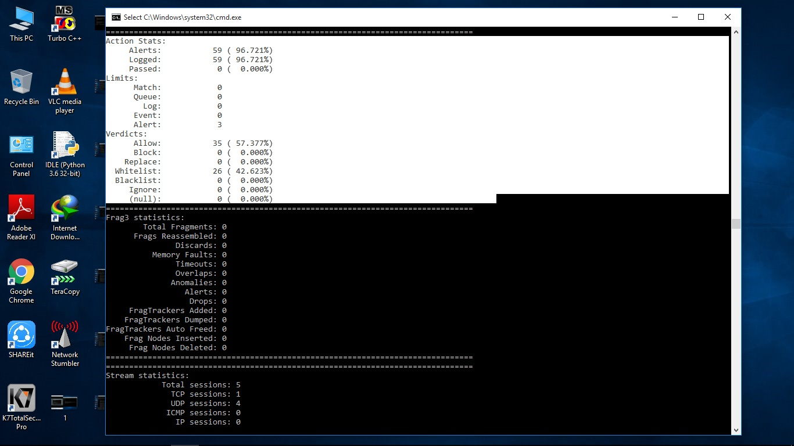

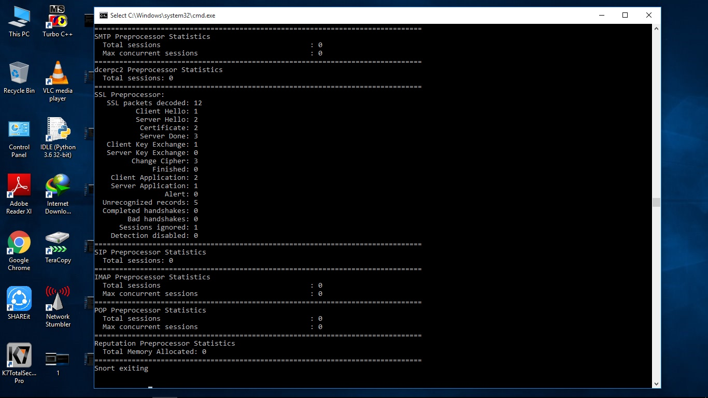

**Result:**

Thus the intrusion detection system(ids) using Snort has been Demonstrated Successfully.